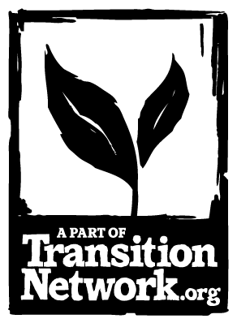
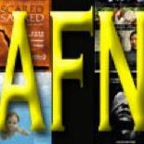
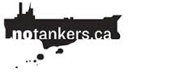


The time is NOW for action. This special evening will feature addresses by …

* Kai Nagata, Energy & Democracy Director for the Dogwood Initiative

* Andrew Moore, co-founder of Transition Sooke and Program Manager for the T’Sou-ke First Nation’s internationally renowned solar power program.

* David Anderson, former Canadian Minister of Fisheries & Oceans and eloquent spokesman for the No Tankers/Pipelines movement in BC.

* Terry Dance-Bennink, JDF point person for Dogwood’s Let B.C. Vote initiative and its bold attempt to trigger an HST-style provincial referendum on crude oil pipeline and tanker proposals.

A public forum presented by Dogwood Initiative, Transition Sooke & Awareness Film Night

Thursday, June 26th, 7 p.m. at St. Rose of Lima Church,
2191 Townsend Rd. in Sooke

The Enbridge Decision and Our Response

