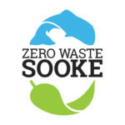
Delegation to District of Sooke Council
Monday, July 10, 2017
Supplemental materials

Zero Waste Sooke respects the District's ongoing commitment to environmental sustainability in the Sooke region and acknowledges the many positive initiatives taken to date. Tonight's delegation wishes to remind council of our three requests last fall, inquire as to what action has been considered to date, and add fresh materials and suggestions to this evolving file.

On Sept. 12, 2016, Zero Waste Sooke, a working group of the Sooke Transition Town Society, appeared before the District of Sooke's Committee of the Whole to present the final report of its "Talk Trash" Open Space public meeting on local waste management issues.

ZWS identified three priority actions from among the report's recommendations that might be tackled in the short and mid-term by the District in association with other levels of government, citizens, community groups and/or private business.

1. RESOURCE RECOVERY CENTRE: "DOS is encouraged to take a lead role in exploring a public/private partnership that will ensure Sooke residents have access to a full-service resource recovery centre that might also include a compost facility, yard-waste depot and related, job-creating micro-businesses."

2. PLASTIC REDUCTION: "DOS to investigate a ban on single-use plastic checkout bags at retail outlets in Sooke as part of a comprehensive campaign to reduce plastic waste."

3. DRINKING FOUNTAINS & PLASTIC BOTTLE REDUCTION: "DOS to install water drinking fountains in strategic locations around town. Suggested locations in priority order: i) Town core (at site of the info map at Evergreen Centre); ii) John Phillips Memorial Park (as part of new washrooms); iii) Ed Macgregor Park; iv) Sooke Flats campground; v) Broomhill Park playground."

Context for District of Sooke support for these proposals

Waste management programs are an integral aspect of municipal business. The work of Zero Waste Sooke compliments the Climate Action Charter (signed by the District of Sooke in February, 2008) and the Community Energy and Emissions Plan (October, 2014).

The 2010 Official Community Plan asks that "Sooke take responsibility for a sustainable, positive community future" (10.1, pg. 56), "provide clean, fresh drinking water for the entire community" (4.10.2i, pg. 57), "support educational programs that create public awareness about our collective environmental responsibility" (4.10.2k, pg. 57) and "encourage and promote the use of cloth or other reusable shopping bags or 100% biodegradable shopping bags in the District of Sooke, with the goal of eliminating plastic bag use" (4.10.3r, pg. 57).

Our proposals are consistent with three pillars of the District's Strategic Plan: "Fiscal Sustainability" (i.e., "build capacity in our community by supporting initiatives that support sustainability"), "Community Planning" and, especially, "Enhancing Community Livability." In the current OCP review process, "Protect the Environment" is the first of the "three big goals for Sooke" identified in the public feedback process.

Reviewing our three asks

1. RESOURCE RECOVERY CENTRE: To be clear, this resource centre is not to be confused with the waste transfer station proposed, debated and ultimately rejected by Mayor Milne's council in the fall of 2014. Instead, the primary goal of the facility would be to recover, reuse and upcycle materials that would otherwise be lost to the landfill. This could be done at a new facility or in partnership with one or more waste-management companies currently operating in the District. We assume the zoning requirements would be M3, though perhaps council might consider (though a public hearing process) a site-specific M2 exemption to allow waste management and recycling.

As a volunteer organization with no paid employees and limited resources, Zero Waste Sooke is prepared to coordinate and provide assistance in bringing stakeholders together to explore the potential and possibilities for a local centre. It's essential, however, that Sooke council takes the initiative in confirming, supporting and pursuing this idea with the involvement of District staff.

-2-

2. PLASTIC REDUCTION:

~ Bag Ban: Sooke council has noted that it is keeping tabs on how the City of Victoria deals with Surfrider Vancouver Island's request for a ban-the-bag bylaw within Victoria city limits. Victoria Mayor Lisa Helps announced last week that a bylaw would be presented to her council for discussion later this summer with a projected implementation date in the fall. (see attached article)

~ Sooke's Big Three Retailers: As we stated at the COW meeting, a ZWS team of adults and young people met last summer with representatives from Western Foods, Village Foods and Home Hardware in Sooke. We wanted to learn more about bagging procedures, the related costs of plastic and paper bags, and how these three businesses work as registered stewards with Recycle BC (formerly known Multi-Material BC). The latter is funded 100 percent by BC businesses and is evidence that retailers are dedicated to reducing their environmental impacts.

Each of the reps we spoke with stated that they'd seriously entertain the idea of a plastic-bag ban locally provided it was a requirement for all retailers in the District. In addition to being a positive action by responsible corporate citizens, a ban would have an impact on their bottom line: each plastic and paper bag taken home by customers costs approx. 7 cents (plastic) and 20 cents (paper).

- Sooke Retail Survey: At council's request, ZWS canvassed a range of local retailers for their views on the subject last fall. The Little Vienna Bakery and A Sea of Bloom support an outright ban on plastic bags. Whiskers & Waggs favoured a ban on heavy-duty plastic while asking that biodegradable plastic bags be permitted. Peoples (now Pharmasave) did not support a ban for various reasons related to store operations. Chain outlets (i.e., Subway) and the local BC Liquor Store are bound by corporate decisions made at head office.

-3-

~ Bring Your Own Bag initiatives: In encouraging shoppers to use canvas shopping bags, ZWS has designed a "BYOB" (Bring Your Own Bag) prototype sign that it would like to see erected in plain sight outside our town's major retail outlets. Western, Village and Home Hardware expressed interest in this idea. A fourth sign might be placed at Cedargrove Mall.

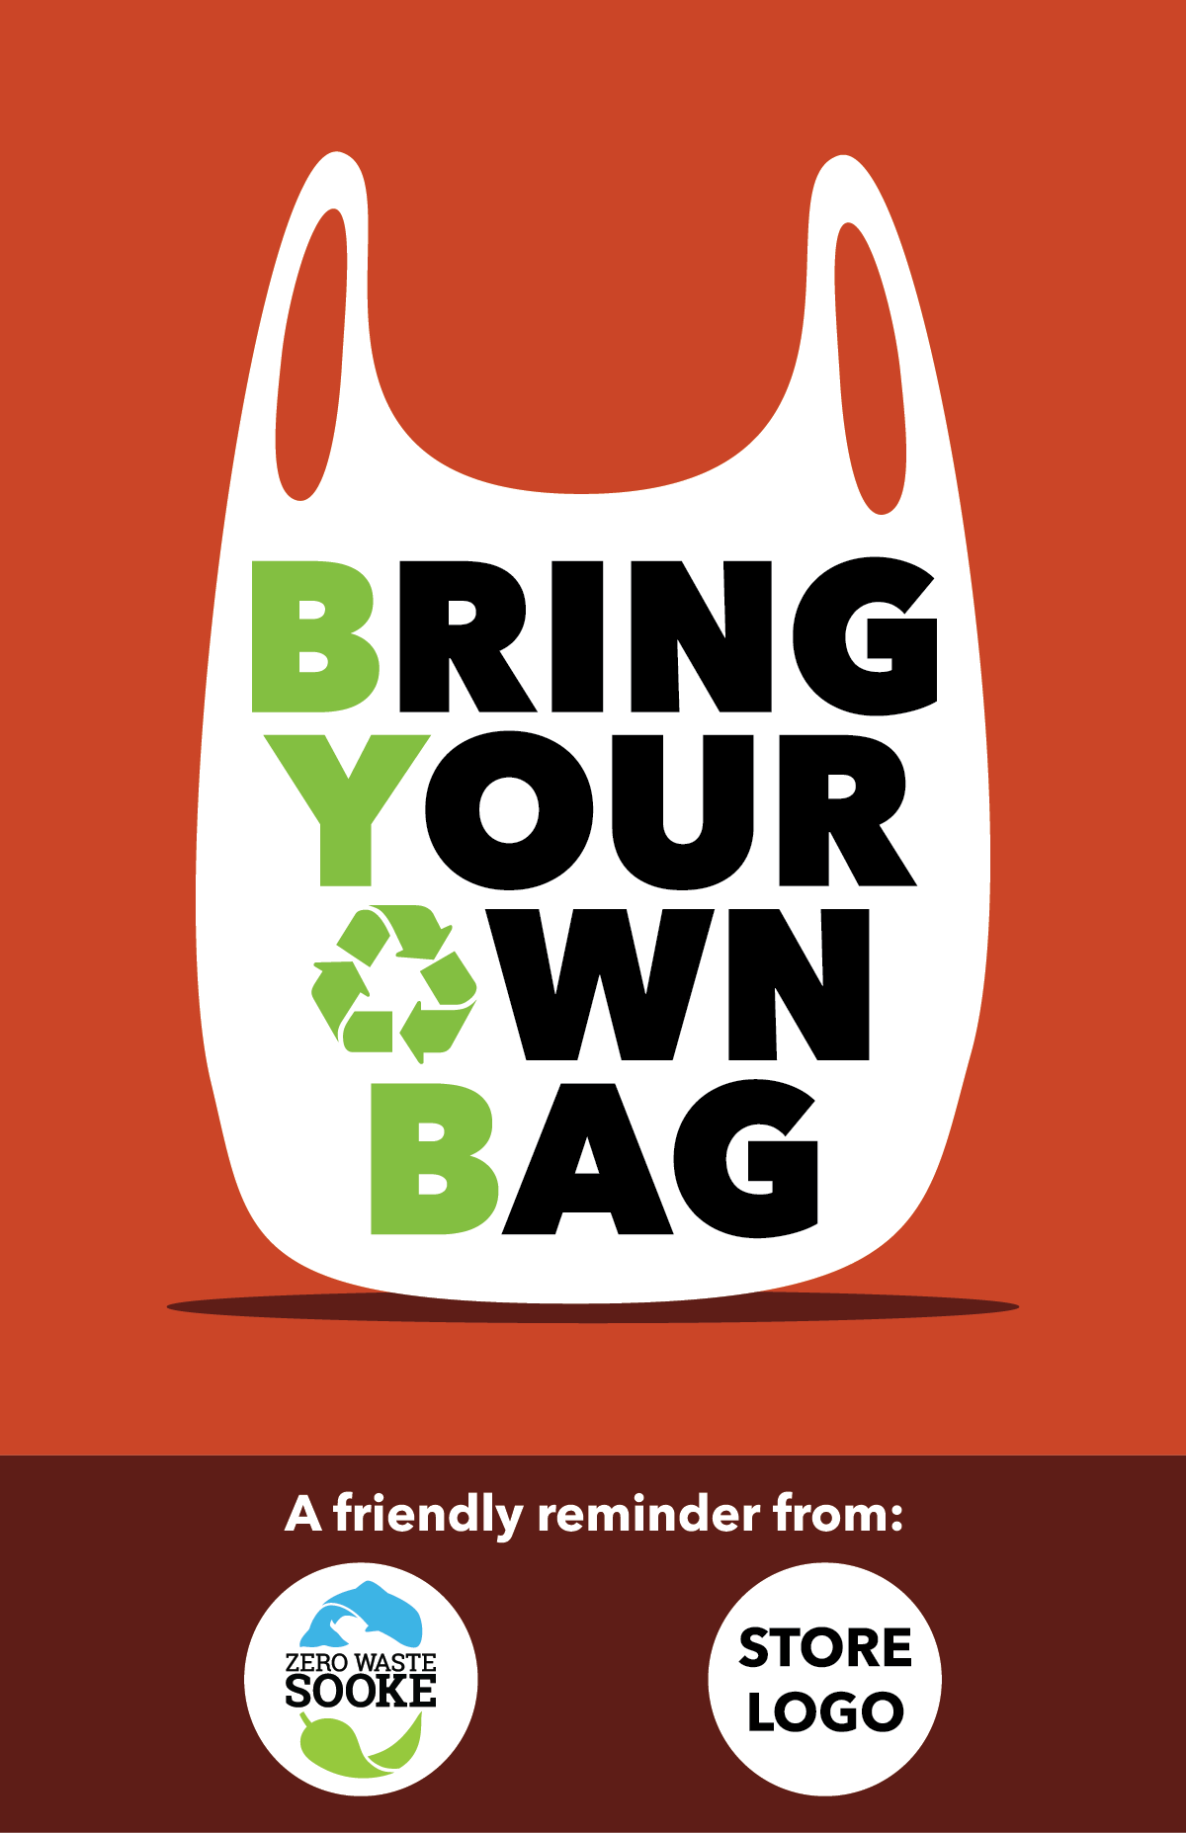

(design for Zero Waste Sooke by Zach Ogilvie/Ogilvie Creative)

Tony Green at Sooke Signs has suggested that the signs be 24" x 16" and be made of aluminum or durable 6mm coroplast. We believe the signs will be an effective educational tool and practical reminder for the numerous Sooke shoppers who have the right intentions but (like us) routinely leave their reusable bags in the car trunk or at home when shopping.

3. DRINKING FOUNTAINS & PLASTIC BOTTLE REDUCTION:

Outdoor public drinking fountains were once the norm in most Canadian communities of our size but are much less commonplace with the rise of the bottled-water industry. According to a recent article in The Guardian newspaper, one million single-use plastic water bottles are sold per minute worldwide. While most are made of recyclable polyethylene terephthalate, "fewer than half of the bottles bought in 2016 were collected for recycling and just 7 percent were turned into new bottles. Instead, most plastic bottles ended up in landfill or in the ocean." ~ https://www.theguardian.com/environment/2017/jun/28/a-million-a-minute-worlds-plastic-bottle-binge-as-dangerous-as-climate-change

Cyclists and hikers can fill water bottles at the Sooke River Road entrance to the Galloping Goose trail. There are indoor water fountains at SEAPARC and in our schools; a water-bottle fill station installed at Edward Milne Community School in 2013 has resulted in approximately 15,000 fewer water bottles sold annually through EMCS vending machines (in the process saving students many toonies).

-4-

i) Outdoor Drinking Water Fountains: We'd like to see one or more fountains installed locally starting with the town centre. Logically, it would be hooked up to city water, perhaps near the info map at Evergreen Mall or, in due course, as part of any public plaza planned for Lot A.

Elkay and Halsey Taylor are the leading manufacturers of three-tier drinking fountains and water-bottle fill stations sold to municipalities in Canada. Vancouver-based sales rep Rod Bennett (cel: 604.454.4738) says that sales of public fountains to schools, institutions and municipalities have skyrocketed in recent years. A variety of models are available: We recommend a three-tiered model that features a water-bottle fill at the top as well as spouts for children and pets. Fountains are now made of a type of stainless steel (316) that resists saltwater corrosion. A freeze resistant model is also available. Prices (installed) range from $5k to $10k per fountain. Discounts are available when ordering multiple fountains.

Bennett can be reached though Elkay's BC distributor Dobbins Sales Ltd. Contact: (604) 525-1090; email delta@dobbinsales.com. A nearby Van Isle wholesaler of water fountains is Bartle & Gibson in Saanich (250.727.9976).

Example:

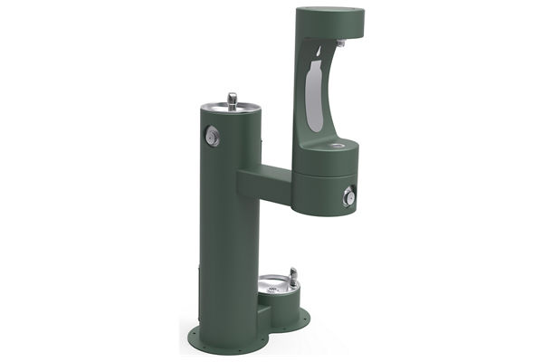

http://www.halseytaylor.com/fillers/fillers-outdoor/4420bf1ldbfrk
"Halsey Taylor Endura II Outdoor Hydroboost Bottle Filling Station
Bi-Lev w/Pet Station, Non-filter, non-refridge, freeze resistant.
Model: 4420BF1LDBFRK $10k

-5-

ii) Water refill cart for public events: Mobile water stations provide free access to fresh drinking water at public events. The CRD has one that it loans out in the region (along with one staff person to run it). The station, as the CRD notes, "encourages everyone to BYORB (bring your own reusable bottle) to stay hydrated, save energy and reduce event waste." The station is popular and books up early every year during summer event season. https://www.crd.bc.ca/service/event-booking

Might the District of Sooke want to purchase its own water station? It could be made available for community events (Canada Day, Bluegrass Festival, the Car Show, Philharmonic Fling, etc.). And when not required in Sooke, it could be outsourced to other communities.

One possibility: The WOW (Water on Wheels) Mobile Water Fill station. Canadian-made stainless steel refill station that connects to hose faucets and fire hydrants. $3,500 + GST. http://wateronwheels.ca/buy-a-station.

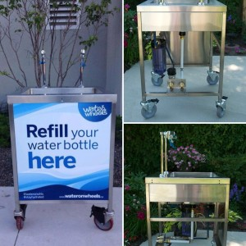

iii) Faucet from a stand-pipe or the outside wall of a gas station: The nothing-fancy solution to drinking water. Either the District could install a stand-pipe in a park location (just as the City of Langford provides a stand-pipe as a water source for dogs at its dog park on Claude Road at Goldstream. Or a local business might be encouraged to install an easy-access water source on-site at the business.

-6-

