Delegation to District of Sooke Council
Monday, March 12, 2018

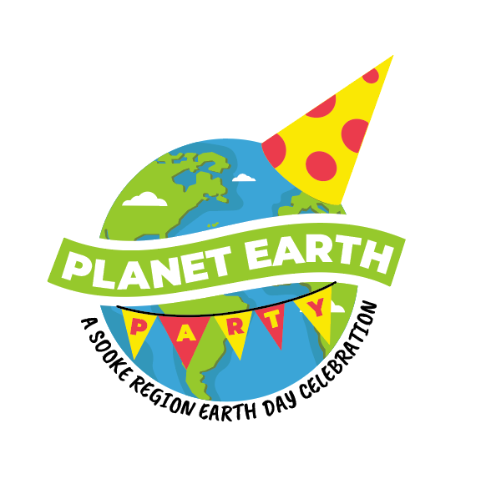PLANET EARTH PARTY
A Sooke Region Earth Day Celebration

Hosted by Transition Sooke and Zero Waste Sooke
in association with the Sooke Fall Fair Society
and Creatively United for the Planet

Sunday, April 22, 2018
Sooke Community Hall

Exhibition: 10 am to 3 pm
Planet Earth Party: 4:30 pm to 8 pm

ABOUT THE PLANET EARTH PARTY (PEP)

This day-long event at the Sooke Community Hall on April 22 will feature exhibitors, non-profits, green vendors, workshops, displays, family activities, food trucks, an upcycled fashion show, a clothing exchange, an art project, entertainers, musicians and more. Sooke's third Repair Cafe will take place downstairs at the hall during the day, and an all-ages Earth Day party is planned for the late afternoon and early evening. Also in the works is a community street clean-up that will ideally involve residents from Beecher Bay to Port Renfrew in a friendly and fair litter-busting competition.

PEP is hosted by Zero Waste Sooke (ZWS) in association with its parent organization Transition Sooke, the Sooke Fall Fair Society and Creatively United for the Planet. As far as we know, this will be the first Sooke-area Earth Day event in approximately 20 years (source: Elida Peers).

The working group of nearly three dozen Sooke region residents (so far) is creating an unpretentious, entirely volunteer-run addition to the thousands of events in 192 countries that will mark the 48th annual Earth Day. PEP follows up on a ZWS Earth Day 2017 street clean-up and is the next step in what will potentially be a series of other regional events leading to Earth Day's 50th anniversary in 2020.

We're confident we can attract a good-sized crowd from the Sooke region along with daytrippers from elsewhere on the South Island. Victoria's Creatively United festival is in hiatus after six successful years. The one other regional Earth Day 2018 scheduled to date that we could find will be on Salt Spring Island.
PEP admission will be by donation at the door. Exhibitor tables are priced at a bargain $10 to $40 based on size and location. We are operating with a modest budget and are seeking sponsorships and grants. Our goal is to break even and/or bank a surplus that will be dedicated to future ZWS iniatitives in the region.

To date (March 8), we have received donations from the Rotary Club of Sooke (to cover our venue rental and insurance costs), Wittich Environmental Services, Interactive Construction and Viridian Energy Cooperative. Phoebewood's Phoebe Dunbar has gifted us with the first of our raffle prizes.
Consistent with the Earth Day Network's international theme for 2018, plastic reduction will be the day's main theme. It's a timely fit here on the South Island where the pushback against single-use plastic has recently led to legislation in the City of Victoria and the promise of more to follow in other regional municipalities, Sooke included.

Seeking a fun, educational, richly experiential Earth Day adventure?
Then make (low-impact) tracks up Sooke on Sunday, April 22.

_____________________________________

Our threefold focus for PEP: Sooke Region Earth Day Celebration

1. Provide more answers and inspiration to ‘the converted’

2. Make it fun enough for the disengaged, and slightly engaged, to be inspired to reduce their individual carbon footprint. In fact, we want to enchant the disenchanted (aka the understandably “I-am-powerless-in-the-face-of-the-realities-of-climate-change" crowd)

3. To leave a legacy donation of some kind, preferably one in each of the communities in the Sooke region

Our working team + collaborators to date includes ...

Marlene Barry (coordinator) with (in alpha order by first name) Anna Smandych Ogilvie, Benjamin Kendrick, Bernie Klassen, Carol Mallet, Carolyn Bateman, Christa Rossner, Dave Gallant, David Mallett, Deb Wood, Donna Patterson, Ellen Lewers, Edith Newman, Eric Hurwood, Frances Litman, Frederique Phillip, Gillian Gravenor, Keli Dunn, Jane Hutchins, Jeff Bateman, Jo Phillips, Joan Hurwood, Leighanne Georgeson, Leslie Hering, Marilyn Montague, Martin Bissig, Mary Dunn, Paula Johanson, Phoebe Dunbar, Randy Welters, Shawna Knight, Tracy Waters, Wendy O'Connor, Zach Ogilvie + thank you to our first wave of sponors: Rotary Club of Sooke, Wittitch Environmental Services, Interactive Construction and Viridian Energy Cooperative.
What we're showcasing, advocating for and promoting at
Planet Earth Party 2018

Environmentally friendly new-economy vendors

Grassroots ingenuity through non-profit community engagement and hard work

Multiple ‘reuse’ approaches and learning opportunities

Zero Waste Sooke's 3rd Repair Café

Inspirational speakers (including Practical Utopian Guy Dauncey)

Plastic-free and near-zero-waste food-truck vendors
.

Carbon emissions reduction processes

Organics diversion techniques

Alternative transportation options

Community clean-ups

Broad community engagement and calls to action

Climate action commitments and promotion

Sustainable energy alternatives

Demonstrating how the personal challenge of establishing green household habits and energy saving measures can be both easier and more fun.

DISTRICT OF SOOKE: PRIMARY ASK

Might the DOS consider financially supporting Planet Earth Party as one of our core sponsors?

The District might want to tap a portion of its Carbon Tax Rebate Reserve Fund (bylaw #601). These funds are designated to “support initiatives to reduce carbon emissions in the District of Sooke.” We believe the reserve contains approx. $7k and that it has not been drawn on since its creation in 2014.

PEP organizers believe that our event will indeed help reduce carbon emissions in the District through public education and the promotion of earth-friendly lifestyle and consumer choices along with direct action via our community street clean-up.

One possibility would be to direct any District contribution not to our general operations budget but towards a TBD "legacy" contribution to the community. Options might include a town centre drinking water fountain as both a public service and to curb the use of water bottle sales locally. Or perhaps the donation of recycling bins or a high-efficiency composter to the Sooke Community Hall, Ayre Manor or a Sooke region school.

SECONDARY ASKS
1. DOS to book an exhibition table(s) at PEP to showcase its environmentally-savvy staff members and showcase the municipality’s green plans, initiatives & programs, i.e. Net Zero municipal operations, Climate Energy & Emissions Plan, unofficial green-building checklist items, bear-proof garbage cans, EV charging stations, etc.

2. Lend the DOS tent for use in our planned outdoor activities

3. Lend DOS vests, gloves & traffic cones for our street clean-up

4. Can we have a copy of the DOS waste management plan to share with the community?

5. Mention of Planet Earth Party on the District website

*** Sincere THANK YOU to the District for waiving its fee to close Eustace Rd.
on April 22 ***
Legislative context for District of Sooke sponsorship of the
Sooke Region Earth Day Celebration

The District of Sooke signed the British Columbia Climate Action Charter in 2008. <clip> “Governments urgently need to implement effective measures to reduce GHG emissions and anticipate and prepare for climate change impacts.”

Climate change is highlighted in Sooke’s 2010 Official Community Plan. <clip> “Establish the importance of energy to all aspects of the community’s social, economic and environmental well-being … demonstrate leadership in sustainable energy.”

Sooke Climate Energy & Emissions Plan approved by council in Oct. 2014. Council priorities: i) Promotion of home retrofits & demand-side management programs; ii) Improved walking infrastructure; iii) Organics diversion from Hartland; iv) Urban containment.

Specific line references and details follow ...

Official Community Plan 2010
4.3.2 (pg. 30/31)

b) “Establish the importance of energy to all aspects of the community’s social, economic and environmental well-being.”

d) “Emphasize the community’s global citizenship (linking local efforts to regional, national and international energy & emissions policy)”

j) “Work with all stakeholders to better understand the local effects of climate change, and identifying both the benefits and impacts on the environment, society and the economy.”

Please note that we believe Transition Sooke, Zero Waste Sooke, the Sooke Fall Fair Society, all our volunteers and every citizen in Sooke region can be considered a “stakeholder” on this critical issue.

Our Earth Day event makes Sooke a part of a renowned and enduring global environmental initiative. It is intended to help us all understand the impacts of climate change … and inspire essential course corrections we must make at personal and community levels.

Sooke Climate Energy & Emissions Plan

In 2014, the council of the day prioritized four action points in the District's Climate Energy and Emissions Plan. One that was to be tackled annually moving into the future was active promotion of "home retrofits and demand-side management (DSM) programs to reduce energy consumption.”

Current rebate programs that District staff could promote at PEP on April 22:

* Fortis BC continues to offer a range of rebates re: home renovations, new home construction, gas hook-ups, and natural gas fireplaces and water heaters.
https://www.fortisbc.com/Rebates/RebatesOffers/Pages/Results.aspx?type=homes&city=Sooke

* A new BC Hydro rebate program for energy efficient appliances will be rolled out in the spring, and PEP would give District staff an opportunity to share the news with Sooke region residents.
https://www.bchydro.com/powersmart/residential/savings-and-rebates/current-rebates-buy-backs/appliance-rebates.html

* Natural Resource Canada's EnerGuide Home Evaluation and BC Hydro's Home Energy Coach programs offer rebates to homeowners when hiring an expert consultant for advice on how best to retrofit and upgrade personal living spaces.
http://www.nrcan.gc.ca/energy/efficiency/housing/home-improvements/5005

Ongoing promotion of these kinds of rebate programs as they arise in turn is one of CEEP's four priorities. The others are: “improve walking infrastructure"; “organics diversion from Hartland Landfill” (which will be spotlighted at a PEP display table); cand “establish urban containment boundaries” to promote town-core density.

Among the optional items in the CEEP master plan for BC municipalities that Sooke did not choose to take on was “long-term deep community engagement (culture change)." This is a good definition of what Earth Day has been doing since the 1970s and which we are attempting to accomplish in our small, patient, realistic way in 2018.

-end-

