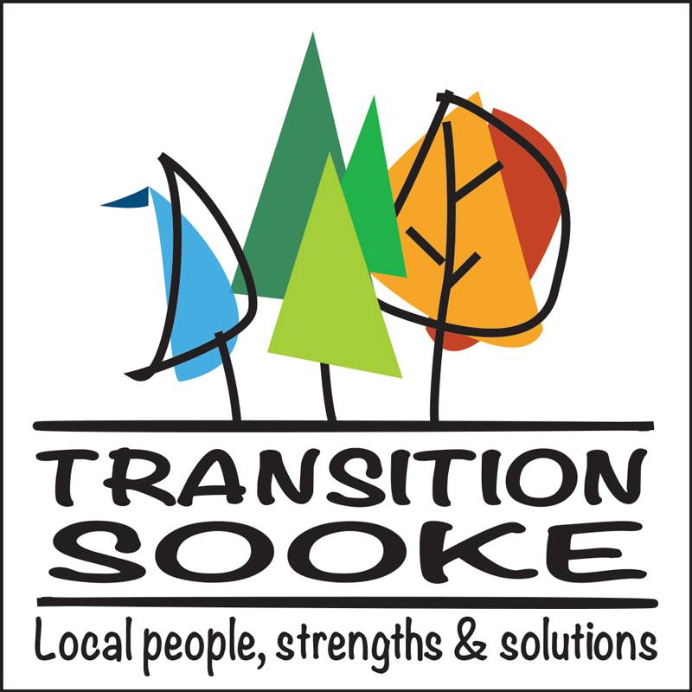

A Year (And A Bit) In Review
Jan. 1, 2017 to Feb. 28, 2018
(all dates listed are 2017 unless otherwise noted)

Board of Directors/Core Team
Paivi Abernethy, Jeff Bateman (president), Martin Bissig (treasurer), David Hannis, Lee Hindrichs, Stephen Hindrichs, Paula Johanson, Andrew Moore, Susan Nelson, Wendy O'Connor, Jo Philips, Olena Russell, Michael Tacon. Honourary member: Bev England.

Miscellaneous
* Eleven monthly meetings in 2017 of the TS Board of Directors & core team
* Daily Facebook and Twitter posts
* Regular (but not overly frequent) email blasts
* Co-sponsor, Stand Up For What You Love rally, Victoria legislature, Feb. 14
* Sooke Seedy Saturday info tables, Feb. 25, 2017 & Feb. 26, 2018
* TS Community Picnic, Ed Mcgregor Park, Aug. 27
* Applefest info table, Sunriver Community Garden, Sept. 17
* Open TS core team meeting, Harbourside Cohousing, Jan. 15, 2018
* Transition Sooke Book Club, debuted Jan. 23, 2018 at Sooke library
* Meeting with Bruce Fogg, constituency assistant to John Horgan, SEAPARC, Jan. 24, 2018
* Compassion In Action: An Introduction to Non-Violent Communications w. Rachelle Lamb, Harbourside Cohousing, Jan. 27, 2018
* Solar Panels: Is It Time?, EMCS, Jan. 30, 2018 (co-presented w. Viridian Energy Co-Operative)
* Let Every Voter Count: A Sooke Information Night on Electoral Reform w. Gail Armitage and Stephen Hurdle (co-presented w. Fair Vote Canada - Greater Victoria); EMCS, Feb. 15, 2018

Speakers Series
* An Evening with Andrew Nikiforuk + screening of Last Stand for Lelu; Awareness Film Night, Jan. 11
* Government 101 w. David Stocks, April 13 (co-presented by the Sooke Chamber of Commerce)
* An Evening with Starhawk, Royal Canadian Legion, May 8
* One Planet Region Conversation w. Trevor Hancock, EMCS, Oct. 23
* Rethinking Traffic As Usual w. Eric Doherty, EMCS, Nov. 20
* No Nukes info night w. Mary-Wynne Ashford & Jonathan Down, Holy Trinity Anglican Church,
Nov. 30 (thanks to Christa Rossner)
* Let's Talk Wolf w. Sadie Parr of Wolf Awareness Inc., EMCS, Jan. 29, 2018 (co-presented w. Project HOWL and InishOge Organic Farm)
* A New Economy screening w. post-film discussion featuring the University of Victoria's Ana Maria Peredo and Viridian's Steve Unger; Awareness Film Night, EMCS, Feb. 7, 2018

Provincial Election All Candidates Forum
April 25, Prestige Hotel, Sooke (co-hosted with the Sooke Chamber of Commerce). Debate featured William Nelson (Van Isle Party), Cathy Noel (Liberal), Brendan Ralfs (Green) and, standing in for the campaigning John Horgan, Maurine Karagianis (NDP).

Sooke Ecohome Tour #2
October 14 in Sooke, Otter Point and East Sooke. Thanks to hosts Gord Fulcher & Lis Johansen, Shyanne Smith (Rainbird Ridge Econest), Michael Cruickshanks & Vibeke Vaerum, Arno Keinonen (Harmless Home), Martin Bissig & Christine Bossi, and Stephen Hindrichs. Also to guests Brian MacNeill (Sun-Mar Composters), Kuan Jian Foo & Steve Unger (Viridian Energy Co-Op), Forest Adam (Homes With Love), Keary Conwright (KC Natural Homes), Frank McKendry (Ridgeco Developments), Michael DuChamplain (Just Biofiber) and Jack Anderson (Anderson GreenPlan).

BC Sustainable Energy Association's 100% Renewable Energy By 2050 Campaign
Marion Pape & Jeff Bateman presented a request for District of Sooke engagement in the BCSEA's campaign (currently adopted by Saanich and the City of Victoria); Committee of the Whole, Nov. 6.

TS Working Groups
(alphabetical order)

Bike Sooke
* Participation in the Capital Regional District's Active & Safe Routes to School program
* Rental notice signs installed on TS bike boxes at T'Sou-ke Park & Ride
* Meetings w. Official Community Plan lead Danica Rice re: cycling & the trail system
* Thanks to Olena Russell for her work as team lead prior to her move to Edmonton

Health & Wellness
* Pending working group led by Michael Cruickshanks

Permaculture Sooke
* Stephen Hindrichs involvement in planning the Sooke Baptist Church's Grace Gardens

Pesticides & the Environment
* Renewed meetings in fall 2017 to explore options for local education and municipal action.
* Team members: Dave & Yvonne Court, Kara Middleton, Alan Dolan, Paivi, Jo & Jeff

Sooke Region Multi-Belief Initiative
* First open meeting at Harbourside, March 4, with guests Mayor Tait and T'Sou-ke elder Shirley Alphonse. Regular working group meetings continued throughout 2017.
* Current team: Eric (Hum) Anderson, Jeff Bateman, Don Brown, Rick Eby, Bruce Hegerat, Troi Leonard, Koshin Sifu Moonfist, Phil Rossner, Michael Tacon and Mark Ziegler.
* Charter For Compassion affirmation drive launched at Sooke Talks, EMCS, Feb. 22, 2018.

Wild Wise Sooke
* Coordinator Debb Read worked closely with BC conservation officers to prevent garbage-related wildlife conflict. Stats again show a major decline in conflict calls.
* Collaborations with District of Sooke, Sooke RCMP, Sooke Food CHI, T'Sou-ke First Nation, Coexisting with Carnivores Alliance, Volunteer Centre, and Sooke Region Museum
* Preliminary Bear Hazard Assessment Report prepared by Environmental Science students at Royal Roads University; second report planned for 2018.
* Press coverage: Sooke News Mirror, Sooke PocketNews, Westshore Voice News, CBC Radio, CFAX, CHEK TV, CTV BC and Global TV
* Planned: Second waste management bylaw request to Sooke council (first quarter, 2018)

Zero Waste Sooke
* Working group led by Wendy O'Connor and featuring Bernie Klassen, Paula Johansen, Anna Smandych Ogilvie, Zach Ogilvie, Jo & Jeff.
* Earth Day community street clean-up of multiple Sooke neighbourhoods, April 22
* Sooke Repair Cafe #1, Sooke Community Hall, May 27
* Delegation to Sooke council, seeking action on 2016 "Talk Trash" Open Space recommendations:
i) plastic bag reduction; ii) drinking fountains; iii) Sooke resource recovery centre; July 10.
* Info tables, Sooke Country Market, June & August
* Victoria Compost Education Centre's Kayla Siefried, Sooke Country Market, July 8
* Secured Mayor Tait's declaration of Waste Reduction Week in Sooke, Oct. 16-22
* BYOB (Bring Your Own Bag) signs erected at four major Sooke retailers, mid-October
* Sooke Repair Cafe #1, Sooke Community Hall, Oct. 21
* Furoshiki gift-wrap workshop w. Wendy O'Connor, Sooke library, Nov. 15
* Planning for Planet Earth Party: A Sooke Region Earth Day Celebration begins in December for Earth Day, April 22, 2018 at the Community Hall (team lead: Marlene Barry; working group includes David & Carol Mallett, Mary Dunn, Ellen Lewers, Phoebe Dunbar, Lesley Hering, Wendy, Bernie, Jo & Jeff)
* Volunteer call-out for fixers for first anniversary Repair Cafe on Earth Day (team lead: Bernie Klassen)

