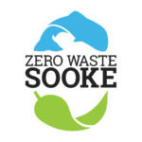

March 5, 2018

Attention: District of Sooke Community Grant Committee
Re: Community Grant Report 2017

Please find supplementary notes about the 2017 community grant given to Zero Waste Sooke, a working group of Transition Sooke. ZWS coordinator Wendy O'Connor has completed the Community Grant Program Final Report Form.

On March 22, 2017, Zero Waste Sooke presented a grant request in the sum of $750 for assistance with the following:

1. Roadside Clean-Up on Earth Day, Saturday, April 22
2. Repair Cafes at the Sooke Community Hall (May 27, October 21)
3. Visit by Victoria Compost Education Centre to the Sooke Country Market (July 8)

Each of our events was offered as a public service either free of charge or, in the case of successful fixes at the Repair Cafes, small donation.

Sincere thanks to the District of Sooke for this support, which is essential to a volunteer-run non-profit operating with a small reserve budget and no full-time staff. We trust that our work has helped the District meet its public education and outreach targets related to climate change.

sincerely,
Jeff Bateman,
President,
Sooke Transition Town Society

ZWS COMMUNITY GRANT 2017 FINAL REPORT

1. EARTH DAY STREET CLEAN-UP
Saturday, April 22, 2017

ZWS organized a community "Team Up to Clean Up" litter blitz of local roadsides, ditches, green spaces and playgrounds on the morning and early afternoon of Earth Day 2017.

After substantial social media, word-of-mouth and local media promotion, some 50 volunteers participated. The group gathered in the parking lot at Sooke Elementary School, where ZWS coordinator Wendy O'Connor and event consultant Koshin Sifu Moonfist shared best-practice safety and health tips. Our volunteers (who ranged in age from several people in their 80s to a number of young people, including a pair of seven-year-olds) then got busy with clean-ups of Saseenos, Kaltasin/Billings Spit, Sooke River Road, Sooke Town Centre, Broom Hill, Whiffen Spit and the John Muir Elementary School area.

Community spirit was raised, and Sooke's reputation as an aspirational Zero Waste community was further established by hard work on an increasingly wet morning. Half of a Sooke Disposal Ltd. dumpster was filled with the collected trash -- including some large pieces found at dumping sites in the region.

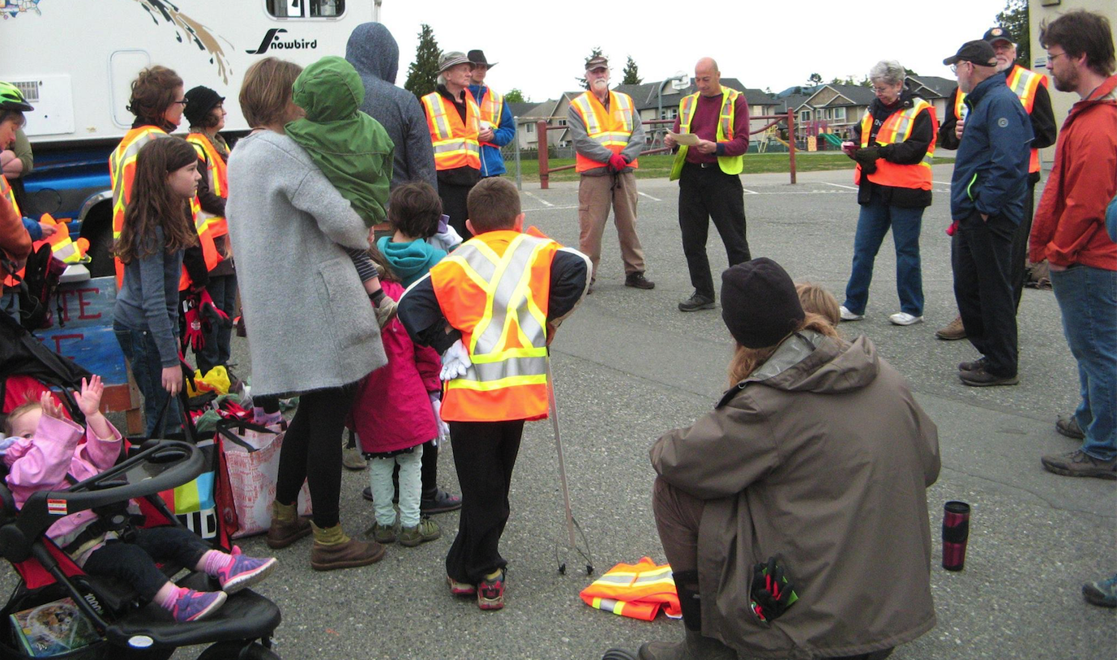
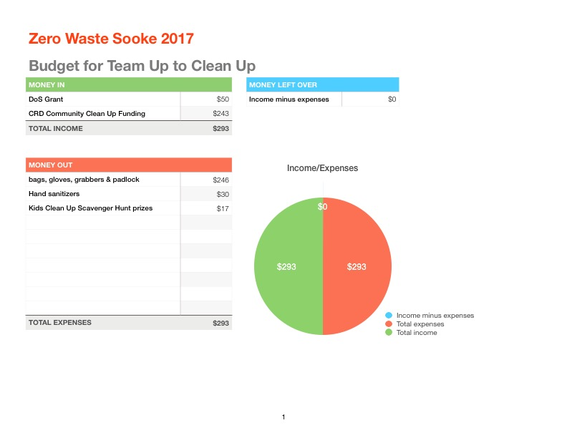

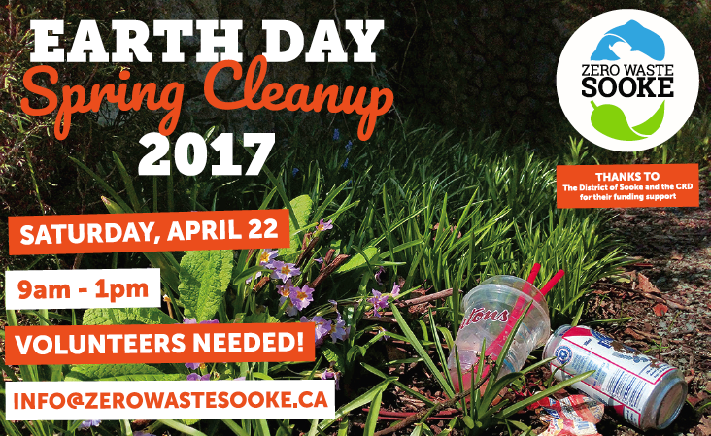

2. SOOKE REPAIR CAFES #1 and #2
May 27, 2017 and October, 21, 2017
Sooke Community Hall

Repair Cafes have become increasingly popular around the world since the first was held in Amsterdam in 2009. They now take place regularly in Victoria and occasionally elsewhere on Vancouver Island. These were the first two in Sooke. ZWS operates its cafes with a license from Repair Cafe International.

Purpose of project
* To add Sooke to the international network of towns with Repair Cafes
* To promote the 5Rs of Zero Waste: Refuse, reuse, repurpose, recycle, rot.
* To share skills and build community connections
* To showcase individuals with repair skills in the Sooke region
* To provide a local solution to a global dilemma
* To show how easy it can be to repair broken items and keep them from landfills

Each of the cafes attracted approx. 150 to 200 people to the Community Hall. About three dozen volunteers were involved in planning, promoting and staffing the two cafes. Volunteer fixers included specialists in fabrics, wood products, small appliances, bikes and fixatives. Fixers included Jeremy Newell, Elgin Ambrose, Paula Johanson, Garrath Morgan, Chris Morgan, Atilla, "Community Mike" Russell, Kasian Rusell, Cyal Baugh and our coordinators Bernie Klassen and Wendy O'Connor. Marion Pettinger demonstrated how to create healthy batches of kombucha and the EMCS Robotics team's Triston Line and Nick Callanan introduced 3D printing.

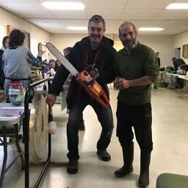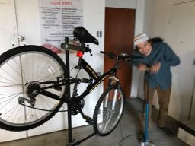

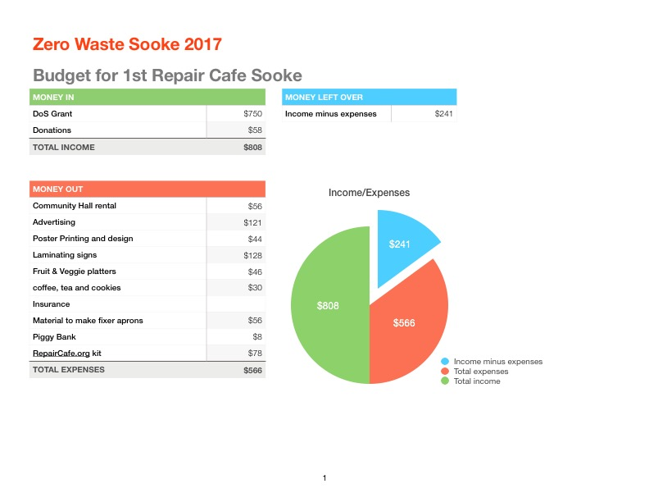

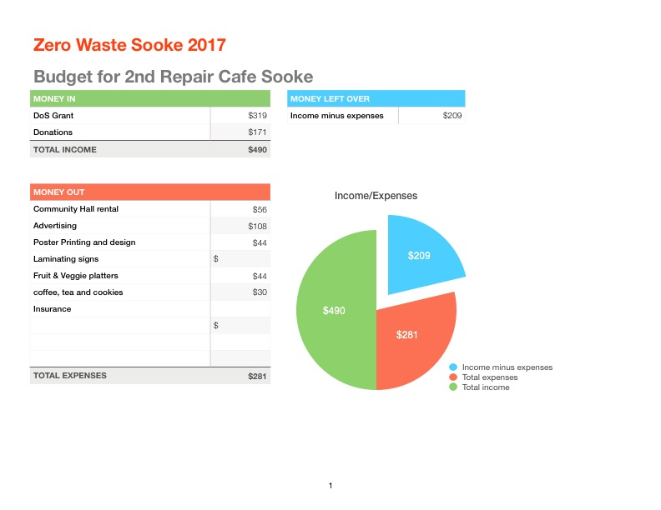

SOOKE REPAIR CAFES 2017 ~ items repaired included:

* nose pieces for eyeglasses
* chainsaw
* sweat pants
* chair
* mitre saw
* pressure cooker
* hair dryer
* lamp
* rice cooker
* purse
* mixer
* picture frame
* electric drill
* alarm clocks
* bikes

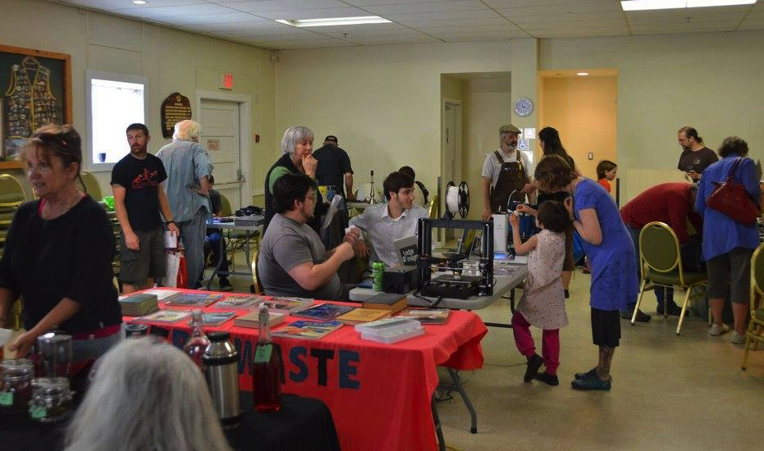

Comments from the Repair Cafes: "The different (work) stations were very interesting. Did a silk screen and loved it. Watched 3-D printing for the first time." ... "Great atmosphere and diversity of offerings - thank you!" ... "We want an encore! Lots of helpful, knowledgeable people. Loved the ways you brought in kids." ... "Makes you want to fix and create all kinds of things (eg, knitting, sewing, silk-screen printing). Very inspiring." ... "My item needs new parts but the volunteer fixer cleaned and adjusted it, and the item may now work for awhile longer now." ... "Practical and good advice." ... "This event was amazing! Chris helped repair our pressure cooker, and educated me on what he did." ... "Great to know it couldn't be repaired!" ... " Marvellous. Do it again, please." ... "Lovely people here." ... "It was awesome!"

Sooke Repair Cafe #1 report by Wendy O'Connor, published on the ZWS website and in the Sooke PocketNews.

“If you could harness all the positive energy and good vibrations in the room at the Repair Cafe, I’m sure it would have powered my sewing machine. Once again, the people of Sooke fill me with joy. A call was put out by Zero Waste Sooke on social media that brought out volunteers of all ages, each one eager to help in some way, from the fixers to the water boy (who did much more than that). A heartfelt thank you to everyone who helped make this event so special, and to the District of Sooke and the CRD for funding support.

You could hear Elgin’s drill, or the thud of a chair leg returning to it’s snug socket, the clacking of knitting needles as Paula and Sarah waited for customers to bring them their darning or woolen mending. Garrath working his magic over kids as they raptly watched him pull apart their parent's mixer and then get it to work again. Garrath’s dad Chris worked cheerfully beside him on other electrical or small engine repairs. Jeremy from Cast Iron Farm was busy getting radios and clocks working again, while outside the Russell family provided a group effort in getting bicycles into better running shape than how they came in. At a station beside them Forest worked with kids at helping them use tools to assemble mini bat houses for them to take home.

Nick and Triston from the EMCS Robotics team fielded questions on the 3D printer they had set up and running, Marion gave a great little workshop on how to save tons of money while taking care of your probiotic health in the making of homemade kombucha. Bernie came up with an awesome design of a raised fist holding a screwdriver — “DIY or Die” is the theme — and was silkscreening t-shirts that people brought along.

Sookies brought the sunshine in through the door with them along with their broken items. The day was a huge success, 28 people filled out registration forms, but we estimate that about 40 people brought multiple items for repair. At least 21 items were repaired and kept out of the landfill. The list included several chairs, a chainsaw, sweat pants, hairdryer, picture frame, purse, electric drill, alarm clocks, pressure cooker, two lamps and a steady series of bikes. Inevitably, some items couldn’t be repaired, but others were diagnosed for further work.

There are over 1300 Repairs Cafes throughout the world today, and more being added each month. This is a gathering movement of people wanting manufacturers to build better products that last longer, and are repairable, and of people recapturing the skills of their parents and grandparents."

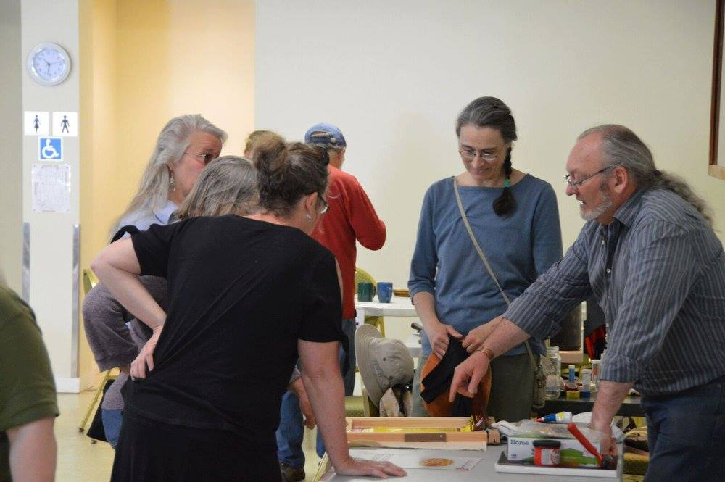

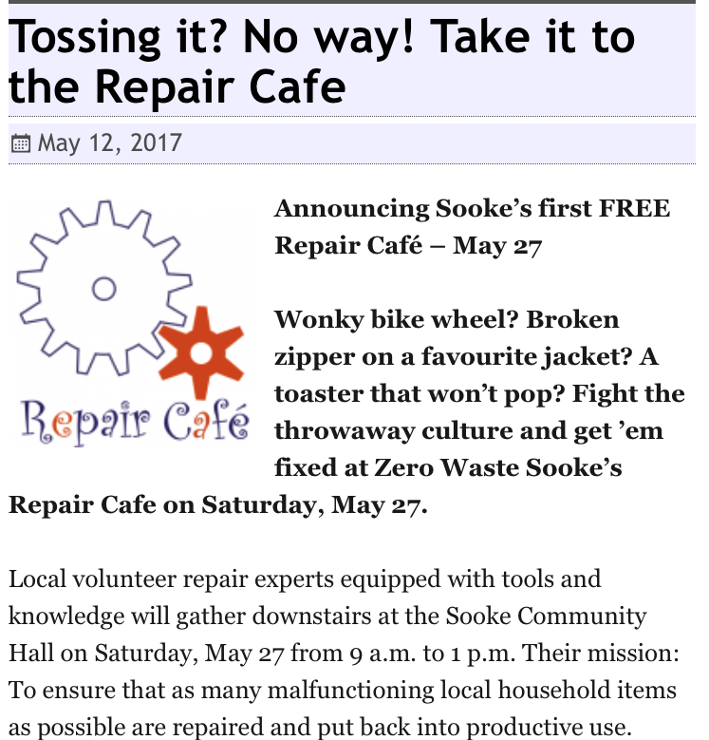

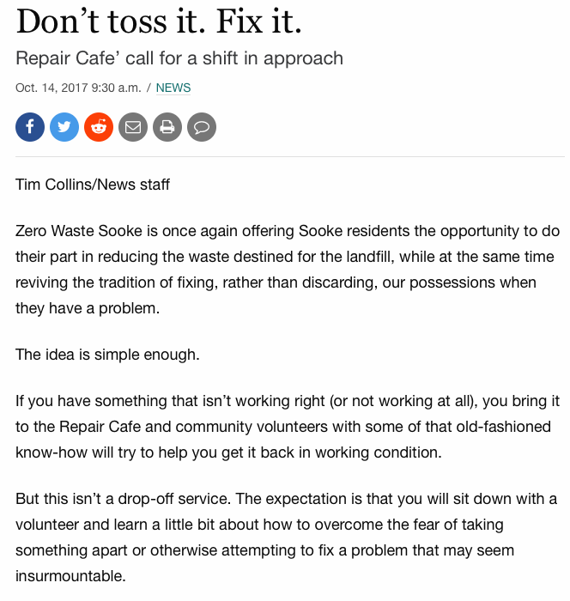

3. SOOKE VISIT BY THE VICTORIA COMPOST EDUCATION CENTRE
Saturday, July 8, 2017 at the Sooke Country Market

For the second year, Zero Waste Sooke invited a representative from Victoria's Compost Education Centre to make a trip to town to share information and best practices about composting. Our rough estimate is that between 100 and 150 people dropped by the Country Market table staffed by the Centre's education coordinator Kayla Siefried and Zero Waste's Bernie Klassen.

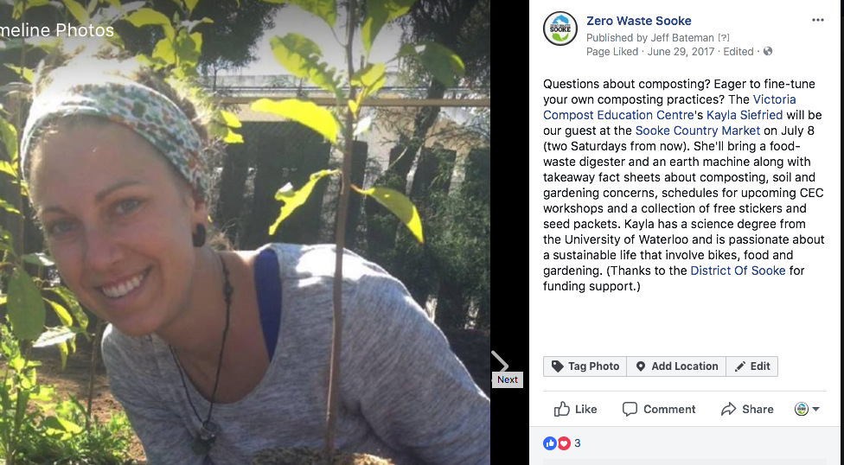

Links to Local Media Articles

Please note that the District of Sooke's financial contribution was referenced in our press releases, posters, website promotion and social media postings.

https://sooke.pocketnews.ca/broken-zipper-faulty-clock-radio-a-toaster-that-wont-zero-wastesookes-repair-cafe-is-your-answer-to-the-throwaway-culture/

https://sooke.pocketnews.ca/next-country-market-features-guest-compost-expert-freetakeaways/

https://sooke.pocketnews.ca/intro-repair-cafe-well-attended-numerous-small-appliancessaved-from-landfill/

https://sooke.pocketnews.ca/tossing-it-no-way-take-it-to-the-repair-cafe/

https://sooke.pocketnews.ca/garbage-gang-and-fixers-wanted-for-spring-clean-up-andsooke-repair-cafe/

https://westshorevoicenews.com/printnews-online/2017-COURTESYissue-
WestShoreVOICENews-V2N29&SVN-V7N18_MAYLONGWEEKENDIssue-
CopyrightWESTSHOREVOICENEWS-May1917-SubscribersWelcome.pdf

https://www.sookenewsmirror.com/community/volunteersneeded-
for-earth-day-clean-up/

https://www.sookenewsmirror.com/community/fight-thethrowaway-
culture-and-get-it-fixed/

https://www.sookenewsmirror.com/news/dont-toss-it-fix-it/

