
FINAL REPORT
SOOKE REGION EARTH DAY 2018 CELEBRATIONS
SOOKE REGION-WIDE CLEANUP Held April 14th
PLANET EARTH PARTY Held April 22nd

OVERVIEW

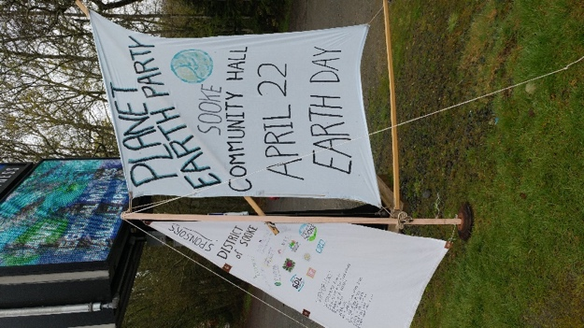
The world-wide theme for Earth Day 2018 was ‘Plastic Reduction’ and we took this to heart. The whole event focused on ‘how can we do this with as little plastic and other waste as possible’. We rethought, reused, reduced, and borrowed throughout the various aspects of putting on a large community event. Rather than order coroplast signs, which we would then have to store, we drew and painted on sheets, including our feature ‘Planet Earth Party’ sail with attached Sponsorship Jib. The sum total of our plastic consumption was a handful of felt pens and the plastic tape from around the boxes containing LED bulbs we purchased locally to give away.

The organizing team started out with a ‘speaking to the converted’ type event plan. The planning grew exponentially as we came to understand the need to ensure this was both a celebration of the earth and of the people in our area doing amazing things to help the planet. A true ‘Earth Day Celebration’ needed to be something that would engage the converted, the slightly-engaged and pique the interest of the not-yet-engaged. Expert guidance was provided by Frances Litman and Creatively United for the Planet Society, coordinators of six previous Earth Day Celebrations in Victoria. The Sooke Fall Fair Association helped in so many ways: providing expert event coordination guidance, lending equipment and supplies, engaging their volunteers, and more.

We provided a multi-faceted Sooke Region Earth Day celebration. The power of positive community action showcased solutions. It was a true community effort involving many organizations and individuals in the Sooke region. We believed we lived up to the event five intentions, which were:

1. A fun, accessible, all-ages celebration of the possibilities for a greener tomorrow
2. Educational focus on how we all can live more sustainably
3. Showcasing residents working together to put the 'unity' back into our Community
4. Representing residents and business owners making the Sooke region look its best
5. Building Sooke's reputation for zero waste and sustainability practices

ABOUT THE SOOKE REGION EARTH DAY CELEBRATIONS Planet Earth Party: A Sooke Region Earth Day Celebration was co-presented by the Sooke Transition Town Society and its working group Zero Waste Sooke in cooperation with the Sooke Fall Fair Association and Creatively United for the Planet. Sincere thanks to our major sponsors: The District of Sooke (foundational support), the Capital Regional District, Home Hardware Sooke, Interactive Construction, Pacific Mobile Depots, Phoebewood, the Rotary Club of Sooke, Sooke Disposal Limited, Speedsource 24 Hour Fitness, VanCity Credit Union, Viridian Energy Cooperative and Wittich Environmental Services.
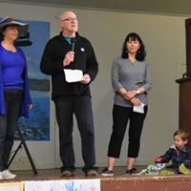
Event Planning Team
Marlene Barry, Coordinator
Jeff Bateman, Promotion/Transition Sooke Liaison
Frances Litman, Chief Advisor
Wendy O’Connor, Region-Wide Cleanup Coordinator
Mary Dunn, Planet Earth Party
Paula Johanson, Blogspot Editor
Bernie Klassen, Repair Café Team Leader
Ellen Lewers, Sooke Fall Fair Liaison
Carol Mallett, PEP Talks Coordinator
David Mallett, Electric Vehicle Liaison
Edith Newman, Upcycled Fashion Show
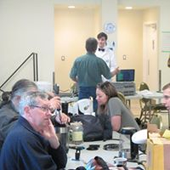
Jo Phillips, Food Vendor Team Leader (with Shawna Knight)
Tracy Waters, Prize coordination
Randy Welters, Business Survey
Lisa Cooper Yakimovich, Clothing Exchange Coordinator

With additional support from ...
Martin Bissig, Financial
Christa Brennan, Inspiration
Rosanne Day, Raffle
Kellie Dunn & the Fraggle Rock-a-Thon entertainers
Phoebe Dunbar, Inspiration
Leslie Herring, Hartland Landfill tour liaison
Peter Jonassen, Music Coordinator
Ron Larson, DJ, Hiway Productions
Sifu Moonfist, Communities Clean-Up
Jean Moncur & Donna Patterson, Upcycled Fashion
Wendy Morton, PEP Poetry Competition
Anna Smandych-Ogilvie, Promotion
Zach Ogilvie, Graphic Design

As with countless events held in our region, many other volunteers took on specific aspects of the celebration, lending a hand where/when they could. We thank them all!
OUTCOMES

PRE-EARTH DAY
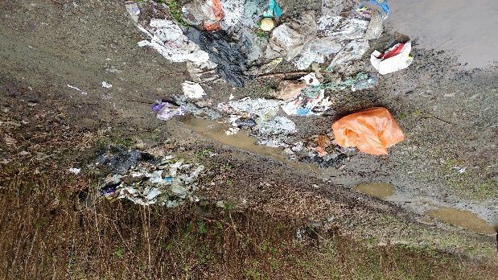
Region-Wide Cleanup:
- Raised awareness for the main Earth Day Event
- Invested in our local economy. Prizes awarded were gift certificates (both purchased and donated) from local area restaurants and cafes.
- Was a friendly competition between communities, and ensured community members came together beyond the actual cleanup.
  - Grand prize awarded to the East Sooke Community Cleanup teams. Earth Day Coordinators prepared a meal and brought it to Aylard Farm on Saturday, June 2nd. Thirty enthusiastic people attended, sharing stories, planning for more cleanup events and enjoying the food and ‘unity of communities’.
  - Second prize of $100 in gift certificates to Village Foods was awarded to the Otter Point Community Cleanup teams, who then donated them to the Sooke Food Bank.
- 5 of 9 communities officially participated (E. Sooke including Spirit Bay, Sooke, Otter Point, Shirley, Pacheedaht)
- 103 people registered and we know more participated, though didn’t register with us. Thank you all!
- Total collected: 129 bags garbage and 24 bags recycling.
- 43.5 km highway and 11 km off road were cleaned
- Wendy and Moonfist drove around in her electric car on cleanup day. People were thrilled to shake his hand and meet him in person. It is clear that his influence extends well beyond the Sooke core.
- Items recycled included: pop & liquor containers (no surprise); plastic jugs, buckets, a plastic wheel barrow, a car battery, lots of metal,
- Garbage items ranged from: 2 mattresses and 2 brassieres (though not in the same location), a fireplace grate, re-bar, car parts, diapers, coat hangers, a man’s leather jacket, and a highchair.

Earth Day Poetry Contest:
- Raised awareness of the main event and attempted to engage the local schools
- Long-time resident and award winning poet, Wendy Morton, coordinated and judged the entries.
- Adult Winner: Heather Phillip & Pauline Hamilton (team)
- Youth Winner: Sophia-Ray Brett, Aged 12

Sooke Region Business Survey:
- 170 surveys were sent out to local businesses
- 37 (22%) responded
- 13 respondents left their contact information as they wish to be involved in further discussions on how to manage waste and recycling better locally.
- The results of this initial survey are supportive of a more thorough assessment of the local waste management situation.

PLANET EARTH PARTY ~ APRIL 22, EARTH DAY 2018

- 1000+ people attended.
- 48 exhibitors set up interactive displays.
- Approx. 30 repairs were completed by the eight fixers at the Zero Waste Sooke Repair Cafe.
- Gave away 250 LED bulbs, 50 reusable carry bags and 50 reusable produce bags.
- The success of the event and fundraising means that we had just over $3,000.00 to put towards legacies in our communities. We are working on the following projects:
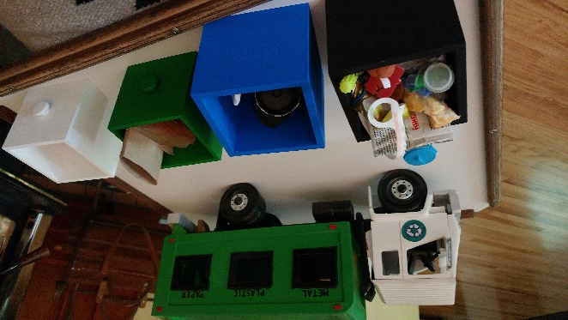
  - Mell Hull, local wooden toy maker, helped us create a kids recycling station, complete with truck, sorting bins and garbage. This is available to events, schools, etc. and has already been used beyond the Earth Day event.
  - Sooke Community Hall and Fred Milne Park – recycling sorting bins
  - E. Sooke Community Hall – bear proof garbage can installed
  - Ayre Manor – rain barrels to reduce water consumption
  - One dozen LED light bulbs to each of the community halls in E. Sooke, Sooke, Shirley and Port Renfrew
- Two sessions of one minute of silence each, this encouraged attendees slow down and focus on the purpose of this gathering
- 204 people entered the draw for a free door prize. 78 asked for further information about Transition Sooke and Zero Waste Sooke.
- Door prize questions: Where Are You From?:
    - Sooke (144), E. Sooke (4), Otter Point(10),
Sassenos (2), Victoria (6), Colwood (3),
Langford (3), Esquimalt (3), Nanaimo (3),
Brentwood Bay (2), Metchosin (2), West Kootenay (1).

Where Did You Hear About Us?:
    - Organizers/volunteers (12), Friends/family (43),
"Everywhere" (5), Grapevine (2),
Facebook (28), Roadside signage (18),
Sooke PocketNews (4), Sooke News Mirror (3),
"Newspaper" (7), Ads (2),
Transition Sooke email (7), Posters (4),
Other (8)
- The blogspot website received 1424 unique hits; the PEP Facebook page was ‘liked’ by 139 people. Boosted Facebook posts were shared 32 times
- Food truck vendors reported good business.

SOOKE REGION-WIDE CLEANUP:
Six (6) of the nine communities that make up the Sooke Region participated in the cleanup: Scia'new First Nation (including Spirit Bay Development), East Sooke, District of Sooke, Otter Point, Shirley and Pacheedaht First Nation.

Additionally, we are aware of three (3) schools organizing cleanups and Earth Day activities: Journey Middle School, John Muir Elementary and Ecole Poirier. Two (2) classrooms from Journey Middle School cleaned up around the school, though were not officially registered with us. They also had a full day with no lights on. John Muir did something similar around their school and along Ella Beach. A grade 4 class at Ecole Poirier created a useful item from recycled materials which were displayed at the event. Clean Air Posters produced for this year's Sooke Fall Fair by students at Sooke Elementary and Saseenos Elementary were on display at the Planet Earth Party.
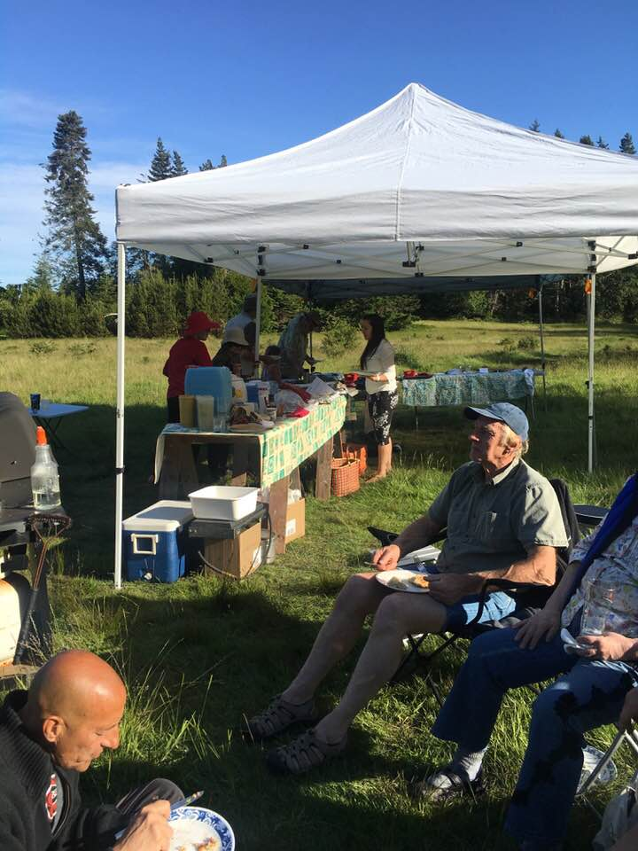
Poor internet and cell phone services in the Port Renfrew area made timely communication with the Pacheedaht representative difficult. While they participated in the cleanup we were not able to receive accurate information on how much they collected on the cleanup date. Wendy O’Connor, Cleanup Coordinator, worked tirelessly to find ways to assist the two ends of our region with their cleanup. She was able to locate scrap metal dealers who would go to Pacheedaht to assist with their cleanup well after the April 14th event date.

A grand prize was awarded to the East Sooke Community Cleanup teams. Our team prepared a meal and brought it to Aylard Farm on Saturday, June 2nd. Thirty enthusiastic people attended, sharing stories, planning for more cleanup events and enjoying the food and ‘unity of communities’.

Second prize of $100 in gift certificates to Village Foods was awarded to the Otter Point Community Cleanup teams. After some discussions it was decided to donate these to the local Food Bank, in part due to growing season making it difficult for folks to come together again.

EARTH DAY POETRY CONTEST WINNERS:
While we received a number of submissions, most were from adults. No schools local actively participated. The winning youth entry was from a 12-year-old girl in Vancouver. We also received submissions from as far away as Africa. If this is promoted in the future it is important to define geographic boundaries for resident submissions

We are looking at two babies and wondering what their future will be.
The oldest has one season, three months, and the youngest, seven weeks.
We could be great grandmas to people like Corbin and Blair.
We’re feeling the guild, mourning their losses:
the forest, the fish, the sea and the clear running streams....
even the air and the rain touched with poison.
What freedoms and pleasures we’ve squandered.
What hardships unnecessary, unearned by those infants
are theirs to inherit?
Why will they have to pay for the greed of the world?
~ Pauline Hamilton and Heather Phillips

Floating, weightless.
The sun makes cracks in the darkness
and peels away fear.
Rippling, shining.
Unity drifts around the mesmerizing blue.
Glowing, life.
Strength and perfection swim between moss.
Blurry. Mysterious.
The fading pillars of beauty are distorted.
Fear. Death.
Humanity falls alongside fish.
Sadness. Disappointment.
A single piece of plastic plunges
down.
~ Sophia-Ray Brett age 12

SOOKE REGION BUSINESS SURVEY:

The coordinating team wanted to find out how engaged the business community was in reducing and recycling waste. This project would have benefited from a dedicated team and additional resources. Randy Welters was the driving force behind getting the project out to businesses. Despite the limited promotion, one article in Sooke Pocket News, we had a 22% response rate and almost half of respondents expressed a desire to participate in further discussions on how to recycle more and manage waste locally, rather than shipping it and further adding to carbon emissions.

Questions asked:

- What types of waste does your business create? (37 responses)
Compostable 40.54% 15 responses
Recyclable paper 86.49% 32
Recyclable plastic or glass 70.27% 26
Other recyclable (metal, etc.) 37.84% 14
Waste/garbage for landfill 67.57% 25
- What is your approximate monthly cost for handling your recyclables & non-recyclables? (36 responses)
$0 - 20 44.44% 16
$20 - 40 19.44% 7
$40 - 60 16.67% 6
$60 + 19.44% 7
- Do you offer options for customer carry bags? (20 responses)
Paper bags 55.00% 11
Plastic bags 60.00% 12
Do you charge for bags 5.00% 1
Do you sell re-usable carry bags 20.00% 4
- Do you have space limitations in handling your business waste? (37 responses)
Yes 56.76% 21
No 43.24% 16
- If you produce compostable waste, what do you do with it? (35 responses)
Take it home to compost 22.86% 8
Give it to somebody else to compost or feed animals 17.14% 6
Pay for it to be taken away by a composting service 14.29% 5
It goes in the garbage for the landfill 14.29% 5
Not applicable 42.86% 15
- What do you consider the main barriers for waste disposal and recycling in the Sooke area? (32 responses)
Businesses aren’t provided with a recycling service 58.39% 19
Short of space inside and out for recycling 34.38% 11
Cost of handing/disposing of waste 37.50% 12
Animals getting into garbage 6.25% 2
Need a community based system 56.25% 18
- Your suggestions for improving the local garbage/waste situation? (35 responses)
Sooke should develop our own waste & recycling area, much like other communities have done 68.57% 24
CRD needs to actively work with Sooke to improve our waste & recycling situation
65.71% 23
Local business owners/managers need to get together to suggestion solutions
22.86% 8
Everything is good, leave it alone 5.71% 2
- What part of the business community are in you? (37 responses)
Restaurant/food service 5.41% 2
General store-based retail 24.32% 9
Home-based retail or service 18.92% 7
Accommodation 5.41% 2
Grocery store 2.70% 1
Service based business 40.54% 15
Other 24.51% 5

PLANET EARTH PARTY
The main event held on Sunday, April 22nd featured live entertainment, food trucks, vendors of eco-friendly products, educational and informational booths, electric cars, composting toilets, clothing exchange, Repair Café, a children’s flash-mob, and more. It was considered a success by attendees, vendors and organizers alike. Feedback was positive and encouraging. We attempted to use the Community Hall space in a slightly different way than other events. The general layout mimicked the quadrants of a compass with a central point. We also displayed informational sheet-banners on the upper walls.

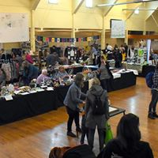
We had free draws (mini-surveys on draw slips) at the two main entrances to the hall. Many people walked by without entering and the downstairs entrance was not always manned. Our attendance count of 1000+ attendees is based on the number of draw slips, general feedback from Food Truck Vendors (based on their experience at other events), and tallies kept by various volunteers over specific time-frames.

For a first-time event, we were overly ambitious and spread ourselves and the activities too thin, especially for the number of volunteers we were able to enlist.

Advertising and Promotion:
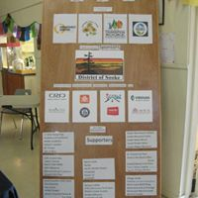
We promoted the event in advance by connecting with local sports groups. In exchange for us having a banner up at their bottle drives, garage sales, etc., we provided additional promotion of their earth-friendly events. For this we created a unique and eye-catching sail banner, adding a ‘Sponsor’ jib once the District of Sooke came on-board as our key sponsor.

Regular press releases were submitted to Sooke News Mirror (SNM), Sooke Pocket News (SPN), Westshore Voice News (WSVN) and the Victoria Times-Colonist (TC). Five weeks prior to the event a schedule of paid advertising was developed with SNM, WSVN and SPN to ensure broad coverage of the event and planned activities. Sooke-area media coverage was good. The Times Colonist provided short previews of the clean-up and PEP itself. We also provided information to the local television and radio stations. That we are aware of, only CHEK News ran a piece on the day of the event. Especially since we were the only Earth Day event on the lower island, this was disappointing.

We provided extensive social media promotion with regularly updated and creative content. A ‘Planet Earth Party’ Event page was created on Facebook and ‘friends’ were invited well in advance. We also created a ‘Planet Earth Party’ FB page for advertising, promotion and discussion. Regular postings on ways to tread more gently on the planet helped develop an interest in the event and create discussions on the possibilities. Paula Johanson also created and managed a BlogSpot page extending our on-line reach for people not on Facebook. Related posts also appreared regularly on the Transition Sooke and Zero Waste Sooke websites as well as FB and Twitter accounts

The District of Sooke was recognized as our key sponsor on Facebook, in advertising, on posters, in emails, on the Sponsor Jib, and at the event. Other sponsors and promoters were acknowledged on Facebook, on posters (sponsors only), in emails and at the event.

Creatively United included the Planet Earth Party in two newsletters that went to more than 4,000 people, ran Facebooks ads and Instagram posts, promoted the event on its events calendar and gave us good coverage on its website and Facebook page.
“Great job everyone! Thank you for the opportunity to be a part of and help share the word about your fabulous first of many Earth Day events to come.”
Frances Litman, Creatively United for the Planet
Rather than consume more plastic, we hand-painted recycled signage, and created fabric sighs. Sooke Food CHI loaned us their road-side signs which we covered with stenciled fabric “Planet Earth Party – This Saturday”.

Large fabric banners were placed at the corner of Sooke Road and Drennan Road, and at the corner of West Coast Road and Sheilds Road, promoting the cleanup and the Planet Earth Party.

One Minute of Silence for the Planet:

On two occasions during the event we coordinated a “1 minute of silence for the planet”. We rang a gong to catch people’s attention and it was interesting to see how long it took to bring the place to silence. After the first minute-of-silence the Amber Academy students conducted a flash mob from their then up-coming Fraggle Rock-A-Thon production, which was well received by the audience and promoted their event to be held the following weekend.
I thought it was a brilliant idea to ring the gong and have a 1 minute silence. It was very profound for me, standing 'in silence' as in yoga/mediation
practice with all those people.
“It made me wonder afterward what would happen if the whole world stood silent just for one minute. “

Electric Vehicle (EV) Display
The EV display was a great success in generating much interest and questions from those who viewed the EV Cars displayed and talked to the car owners.
A big thank you is owed to the Victoria EV Club who graciously offered to display several of their cars. A special thanks to Arno Keinonen, EV Club Vice-President and to Lisa Locke, club secretary for their helpful advice and expertise in setting up the EV car display.
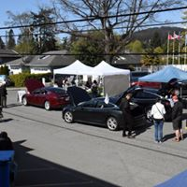
Sooke resident, Alan Dolan offered to provide rides in his newly acquired first generation (2014) Nissan Leaf. A separate parking area was reserved for Alan so that he would not have to deal with the closed off area of Eustace Road.
Finally, Kevin Belanger of Tesla Tours Victoria displayed his Tesla Model S. He was very generous providing a $300 gift certificate for the silent auction.
This was possibly the largest collection of Electric Vehicles on display in a South Island Earth Day celebration to date.

Upcyled Fashion Show & Dance:
Generally, we were too ambitious stretching out over the day. We were warned about this but wanted to try something a little outside of the box. Sadly, the dance and fashion show held later in the day were poorly attended and we would not organize the event this way again.

Feedback from organizers of the upcycled fashion show was mixed. While they were glad they carried on with the show, we were all disappointed with the attendance (under 100 people). The question was raised about whether or not there was enough interest in upcycling clothing or if it was more about timing and scheduling.

Given the level of activity and noise in the hall during the day, the organizers initially felt the fashion show wouldn’t have worked as part of the day’s activities. In retrospect it would be better to find a way to work it into the daytime agenda.

Generally, we were just trying to fit too much in one day and one event. Suggestions were that we just don’t bother with a dance or consider doing it on a different day.

Draw & Silent Auction:
Unfortunately, we did not get our Gaming application submitted in time to sell advance raffle tickets for the Phoebewood bowl (value $1,500) and do it justice. Phoebe graciously provided a smaller bowl (value $500) and tickets were sold at the event. With thanks to Rosanne Day, we sold 418 tickets at $2.00 each in one day, netting us $836.00.

The silent auction was relatively easy to do and we had a wide range of items donated, some at the last minute.
Clothing Exchange:
Generally, it went really well. If it was done again, better signage and a warmer location are recommended.

Sponsorship:

Sixty-six (66) businesses in total were involved as event sponsors ($250+) and supporters (under $250) through funding or in-kind support.

Sponsors ($250 +)
- District of Sooke
- Interactive Construction
- Viridian Energy Cooperative
- Wittich Environmental Services
- Sooke Home Hardware
- CRD
- VanCity Credit Union
- Speed Source Fitness
- Tesla Tours
- Juan de Fuca EA residents - grant in aid

Supporters (under $250)

- 17 Mile House Pub
- Academy of Excellence
- Amber Academy
- Artisan’s Garden
- BC Transit
- Bits of Bliss
- Café in Spirit Bay
- Cathy's Corner
- Dakini Tidal Wilds
- Edith Newman
- Glenrosa House in Metchosin
- Go with the Flow Technologies
- Great Canadian Dollar Store
- Guy Dauncey
- Hara Sushi
- HOWL Project
- Jenny’s Country Pantry & Tea Shop
- Kelz Sweet & Savory Bake Shop
- Little Vienna Bakery
- Livin’ the Dream Farm
- Mai Mai's Bistro
- Mom's Café
- Nyoka
- Pacific Mobile Depot,
- Pizzability
- ReMax Camoson
- Route 14
- SEAPARC
- Serious Coffee
- SFRS Community Thrift Store
- Sheila’s Coastal Crunch
- Shirley Delicious
- Sooke Buy & Sell,
- Sooke Family Resource Society
- Sooke Montessori School,
- Sooke Mountain Cycle,
- Sooke News Mirror
- Sooke Pocket News
- Sooke Region Museum
- St. Vincent de Paul
- Stick in the Mud Coffee House
- Stoked Wood Fired Pizza
- Tomi's Home Cooking: Port Renfrew
- Touch of Class Chimes
- Village Foods
- Vivienne: Australian Healing Master
- West Coast Refill Shop,
- Westcoast Grill at Prestige
- Westcoast Natural Foods
- Western Foods
- Weston A. Price Foundation
- Westshore Voice News
- Wild Mountain Food & Drink
- Windsor Plywood
- Wood Stoked Pizza in Shirley
- Zero Waste Emporium

Musicians
I think it was really fun, thanks for creating such a fun Sooke tradition. I hope it continues, after all there are so many farmers, eco conscious, curious, crafty, talented, hardworking, woke folks in Sooke, surely we can make a little impact together. Attendee

Excellent array of local talent assembled by the Sooke Music Festival's Peter Johanseen. Thank you to (in order of appearance) Bob Menzies, The Ed Fury Band, Eric & Linda James and Gord Phillips. Given the good weather, perhaps the dance should have been outside in the street.

We had an impromptu cellist (Dusty Townsend, aka Fish in A Bird Cage) perform on the stage indoors. He was well received and added light background music to the occasion.

Promotion of BYOE (Bring Your Own Everything). Despite some advance promotion, we're told nobody brought their own dishes to the food trucks. Perhaps this can be promoted more for future events.

Food Trucks
With a first-time event it is difficult to judge how many people will come. Apparently, the rule of thumb for food trucks is one truck for 1000 people, based on 10% of those purchasing food. We had 4 trucks and all food vendors indicated that they did reasonably well and would like to be invited again. This would indicate that we may have had many more than the estimated 1000 attendees. The food truck location near the music was great and the tents and seating in the area were well used.

PEP Talks
In a space of 5 hours, nine PEP Talks ran consecutively. This proved to be overly optimistic so that when a talk ran overtime, that and other interruptionsset everything else running late. Each session was very well received. Audiences varied in size from 5 or 6 to about 15-20 people. Each speaker inspired audience participation during allotted time for Q and A at the end. There were possibly too MUCH choice of things to do. The PEP Talks, for instance, could have been scheduled as a standalone event on a separate date. One person noted that it was a “browser” festival that wasn’t as focused as it might have been.
Volunteers
We used VolunteerSignup.org to create on-line signup for positions. This was helpful though we still ended up short on volunteers.

Some volunteers were unaware that we had food for them and some vendors came down for the free food. One person, unknown to the organizers, spread the word to the Vendors that there was free food downstairs. Despite signs indicating ‘Volunteer Support Area’ it apparently wasn’t clear to them that it was only for the volunteers. It was suggested we provide slips to all volunteers. These would be shown or turned in when they come down for refreshments.

-end-

