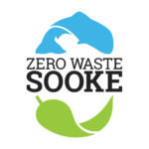
Delegation to District of Sooke Council
Monday, July 9, 2018

Zero Waste Sooke appreciates the District's ongoing commitment to environmental sustainability in the Sooke region and acknowledges the many positive initiatives it has undertaken to date.

Tonight's delegation wishes to:
i) share outcomes from our Sooke Region Earth Day Celebrations in April, 2018;

ii) revisit the three 'asks' we first raised with council on Sept. 12, 2016 and repeated in our delegation of July 10, 2017.

Zero Waste Sooke was founded in January, 2015 as a working group of the Sooke Transition Town Society (aka Transition Sooke).

i) Sooke Region Earth Day Celebrations
Our thanks to the District of Sooke for its generous foundational funding for the Earth Day Celebrations that we co-presented with Transition Sooke, the Sooke Fall Fair Society and Creatively United for the Planet. A final report and draft financial statement is filed with this submission. In short, it was a true made-in-Sooke, volunteer organized and executed event in the tradition of many events that preceded it. We believe we met our objectives to a fair degree and further established Sooke as a region that cares deeply about the environment.

The two main components of the event were ...

Communities Clean-Up, Sat. April 14
* Six of nine Sooke Region communities participated: Scai-new First Nation (including Spirit Bay Development); East Sooke; District of Sooke; Otter Point; Shirley; and Pacheedaht First Nation).
* 103 people of all ages in the region registered for the clean-up. Several dozen more participated but did not register.
* 134 bags garbage and 25 bags recycling were collected
* Approximately 43.5 km of Hwy 14, 4.5 km beachfront and 31 km of secondary & off-road were cleaned.
Planet Earth Party ~ Sooke Community Hall, Sun., April 22 (Earth Day)

* An estimated 1,000 people attended
* 48 exhibitors set up tables inside the Community Hall
* We gave away 250 LED lightbulbs, 50 reusable carry bags and 50 reusable produce bags
* Approx. 30 repairs were completed by the eight fixers at the Zero Waste Sooke Repair Cafe
* Extensive media coverage (including Victoria Times Colonist). Blogspot website received 1424 unique hits; the Facebook page was liked 139 times; boosted FB posts were shared 32 times.

FINANCIAL OUTCOMES + COMMUNITIES LEGACY FUND

Income: $12,896.76
Expenses: $12,896.76
Reserve for Community Legacies Fund: $3,771.53
Reserve for future Earth Day projects: $730.00
(draft financial attached with final report)

In our budgetary planning, we earmarked any net proceeds to two reserve funds: i) Future Earth Day events (20 percent of net proceeds, or $730.00); and ii) Our 'Communities Legacy Fund' (the remaining $3,771.53) which encourages and underwrites green initiatives in Sooke region public spaces. We have notified a range of local groups and institutions about this fund, and the following have responded to date:

i) East Sooke Community Hall -- bear-proof garbage can

ii) Ayre Manor -- a pair of rainwater collection barrels

iii) Fred Milne Park -- recycling bins at concession stand*

iv) Community Hall -- recycling bins upstairs and down*

v) Art Morris Park -- recycling bins at concession stand*

(* We will be meeting with the Sooke Community Association in September to discuss the above three locations; one affordable option, recommended by SEAPARC, is the Busch Systems International (Barrie, Ont.) 'Waste Watcher Quad' four-bin system at approx. $400 each.)

vi) Sets of LED light bulbs have been given to the four community halls in the region: East Sooke, Sooke, Shirley and Port Renfrew.

ii) Revisiting 'Asks' from the 'Talk Trash' Community Meeting

In May, 2016, ZWS hosted its "Talk Trash" Open Space public meeting on local waste management issues. http://zerowastesooke.ca/cow-presentation/

Community members identified a wide range of possible actions and honed in on three consensus priorities that might be tackled in the short and mid-term by the District in association with other levels of government, citizens, community groups and/or private business.

This is a primetime for action given the range of grants available from the Province of BC, the federal government and the Federation of Canadian Municipalities' Green Municipal Fund.

Parts of the following are carried over from our earlier presentations. The bulk of new material here relates to the CRD and City of Victoria single-use plastic bag reduction bylaws.

1. SINGLE-USE PLASTIC REDUCTION: "DOS to investigate a ban on single-use plastic checkout bags at retail outlets in Sooke as part of a comprehensive campaign to reduce plastic waste."

2. DRINKING FOUNTAINS & PLASTIC BOTTLE REDUCTION: "DOS to install water drinking fountains in strategic locations around town. Suggested locations in priority order: i) Town core (at site of the info map at Evergreen Centre); ii) John Phillips Memorial Park (as part of new washrooms); iii) Ed Macgregor Park; iv) Sooke Flats campground; v) Broomhill Park playground."

3. RESOURCE RECOVERY CENTRE: "DOS is encouraged to take a lead role in exploring a public/private partnership that will ensure Sooke residents have access to a full-service resource recovery centre that might also include a compost facility, yard-waste depot and related, job-creating micro-businesses."

Context for District of Sooke support for these proposals

Waste management programs are an integral aspect of municipal business. The work of Zero Waste Sooke compliments the Climate Action Charter (signed by the District of Sooke in February, 2008) and the Community Energy and Emissions Plan (October, 2014).

The 2010 Official Community Plan asks that "Sooke take responsibility for a sustainable, positive community future" (10.1, pg. 56), "provide clean, fresh drinking water for the entire community" (4.10.2i, pg. 57), "support educational programs that create public awareness about our collective environmental responsibility" (4.10.2k, pg. 57) and "encourage and promote the use of cloth or other reusable shopping bags or 100% biodegradable shopping bags in the District of Sooke, with the goal of eliminating plastic bag use" (4.10.3r, pg. 57).

Our proposals are consistent with three pillars of the District's Strategic Plan: "Fiscal Sustainability" (i.e., "build capacity in our community by supporting initiatives that support sustainability"), "Community Planning" and, especially, "Enhancing Community Livability." In the current OCP review process, "Protect the Environment" is the first of the "three big goals for Sooke" identified in the public feedback process.

Reviewing our three asks

1. PLASTIC REDUCTION

~ Single-Use Plastic Bag Regulation: Sooke council noted last year that it would be keeping tabs on how the City of Victoria proceeds with its Checkout Bag regulation. Council was also anticipating the creation of a model bag bylaw by the Capital Regional District.

The CRD model bylaw was included in the Environmental Services Committee agenda dated Sept. 13, 2017. As Esquimalt Mayor Barb Desjardins noted at the meeting: "This is a model bylaw that municipalities can take under advisement and choose to pursue if they so desire." A copy of the bylaw can be found here: https://www.crd.bc.ca/about/board-committees/board-committees-and-commissions/environmental-services-committee.

The CRD report explained, "an emerging topic of interest is the management of single-use items, such as the City of Vancouver’s single-use item reduction strategy aimed at disposable cups, takeout containers, shopping bags and plastic disposable straws. Single-use plastics are also attracting national and international attention."

Eliminating single-use plastic is a global priority, and was the theme of Earth Day 2018 internationally. United Nations Climate Change Director Achim Steiner has called for a world-wide ban on plastic shopping bags; representatives from 200 nations passed a resolution at the UN Environmental Assembly this year to eliminate plastic pollution from oceans. Bag bans and/or taxes have been instituted in recent years in Kenya, Taiwan, the UK, Zimbabwe, Rwanda, Australia, France and Morocco. There are anti-bag regulations in 133 US cities.

On Jan. 1, 2018, Montreal became the first major Canadian city to institute a ban on lightweight plastic bags with a thickness of less than 50 microns; just 14 percent of the roughly 2 billion bags used annually in the Montreal region are recycled, figures consistent with national and international averages.

This June, Canada, France, Germany, Italy, Britain and the European Union endorsed the G7 ocean plastic charter, which calls for signatory countries to reduce the use of plastics and, where alternatives are not available, find ways to include more recycled materials in the plastics they do use.

The City of Victoria's bylaw went into effect on July 1 following a BC Supreme Court decision that rejected a challenge by the Canadian Plastic Bag Association. Oak Bay, Saanich and Esquimalt were among CRD municipalities taking a wait-and-see approach pending the resolution of this case. On June 18, the court upheld the rights of BC municipalities to i) regulate business transactions within their jurisdictions; and ii) manage the local waste stream.

City of Victoria 'Reducing Single Use Plastic Bags" webpage (bylaw text included): http://www.victoria.ca/EN/main/residents/climate-change/Reducing-Single-use-Plastic-Bags/retail-toolkit.html

City of Victoria "Retail Toolkit" "developed to help businesses educate their staff and customers about Victoria's Checkout Bag Regulation Bylaw."
http://www.victoria.ca/EN/main/residents/climate-change/Reducing-Single-use-Plastic-Bags/retail-toolkit.html

~ Public Awareness & Education ~ Bring Your Own Bag (BYOB) signs: Many Sooke residents are keen to bring their own canvas shopping bags -- provided, that is, they remember to get them from their back seats and car trunks before entering stores.

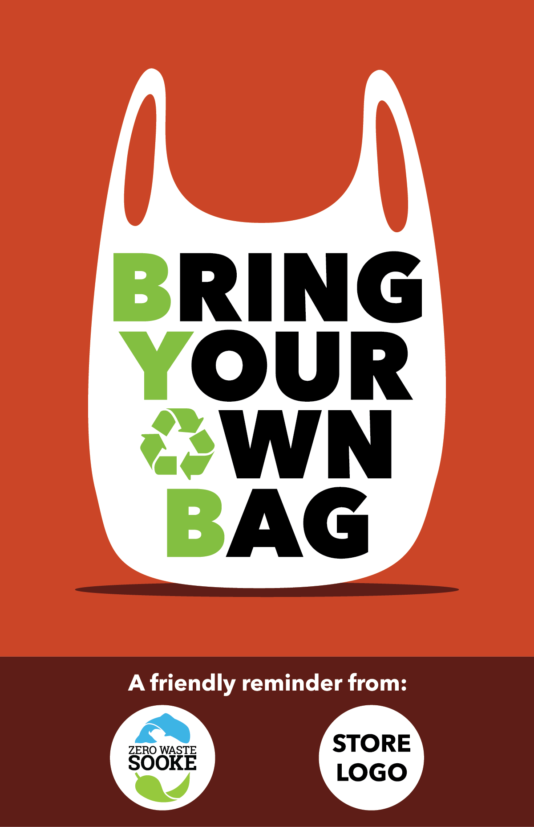
(design for Zero Waste Sooke
by Zach Ogilvie/Ogilvie Creative)

Our colourful reminders to BYOB were posted prominently outside Western Foods, Village Foods, Pharmasave and Home Hardware in the fall of 2017. These leading local retailers enthusiastically supported this initiative; all are registered stewards with Recycle BC. The latter is funded 100 percent by BC businesses and is evidence that retailers are dedicated to reducing their environmental impacts.

- Sooke Retail Survey: At council's request, ZWS canvassed a range of local retailers for their views on the subject in the fall of 2016. The Little Vienna Bakery and A Sea of Bloom supported an outright ban on plastic bags. Whiskers & Waggs favoured a ban on heavy-duty plastic while asking that biodegradable plastic bags be permitted. Peoples (now Pharmasave) did not support a ban for various reasons related to store operations. Chain outlets (i.e., Subway) and the local BC Liquor Store are bound by corporate decisions made at head office.

2. DRINKING FOUNTAINS & PLASTIC BOTTLE REDUCTION

Outdoor public drinking fountains were once the norm in most Canadian communities of our size but are much less commonplace with the rise of the bottled-water industry. According to a recent article in The Guardian newspaper, one million single-use plastic water bottles are sold per minute worldwide. While most are made of recyclable polyethylene terephthalate, "fewer than half of the bottles bought in 2016 were collected for recycling and just 7 percent were turned into new bottles. Instead, most plastic bottles ended up in landfill or in the ocean." ~ https://www.theguardian.com/environment/2017/jun/28/a-million-a-minute-worlds-plastic-bottle-binge-as-dangerous-as-climate-change

Cyclists and hikers can fill water bottles at the Sooke River Road entrance to the Galloping Goose trail. There are indoor water fountains at SEAPARC and in our schools; a water-bottle fill station installed at Edward Milne Community School in 2013 has resulted in approximately 15,000 fewer water bottles sold annually through EMCS vending machines (in the process saving students many toonies).

i) Outdoor Drinking Water Fountains

Sincere thanks to the District for making provisions for a three-tier (adult, child and dog) water bottle fill station as part of the new washrooms to be installed at John Phillips Memorial Park. We also appreciate consideration of same at a new restroom proposed near the Whiffin Spit parking lot.

We'd like to see one or more fountains installed locally starting with the town centre. Logically, it would be hooked up to city water, perhaps near the info map at Evergreen Mall or, in due course, as part of any public plaza planned for Lot A.

Elkay and Halsey Taylor are the leading manufacturers of three-tier drinking fountains and water-bottle fill stations sold to municipalities in Canada. Vancouver-based sales rep Rod Bennett (cel: 604.454.4738) says that sales of public fountains to schools, institutions and municipalities have skyrocketed in recent years. A variety of models are available: We recommend a three-tiered model that features a water-bottle fill at the top as well as spouts for children and pets. Fountains are now made of a type of stainless steel (316) that resists saltwater corrosion. A freeze resistant model is also available. Prices (installed) range from $5k to $10k per fountain. Discounts are available when ordering multiple fountains. Bennett can be reached though Elkay's BC distributor Dobbins Sales Ltd. Contact: (604) 525-1090; email delta@dobbinsales.com. A nearby Van Isle wholesaler of water fountains is Bartle & Gibson in Saanich (250.727.9976).

ii) Water refill cart for public events: Mobile water stations provide free access to fresh drinking water at public events. The CRD has one that it loans out in the region (along with one staff person to run it). The station, as the CRD notes, "encourages everyone to BYOB (bring your own reusable bottle) to stay hydrated, save energy and reduce event waste." The station is popular and books up early every year during summer event season. https://www.crd.bc.ca/service/event-booking

Might the District of Sooke want to purchase its own water station? It could be made available for community events (Canada Day, Bluegrass Festival, the Car Show, Philharmonic Fling, etc.). And when not required in Sooke, it could be outsourced to other communities.
One possibility: The WOW (Water on Wheels) Mobile Water Fill station. Canadian-made stainless steel refill station that connects to hose faucets and fire hydrants. $3,500 + GST. http://wateronwheels.ca/buy-a-station.

iii) Faucet from a stand-pipe or the outside wall of a gas station: The nothing-fancy solution to drinking water. Either the District could install a stand-pipe in a park location (just as the City of Langford provides a stand-pipe as a water source for dogs at its dog park on Claude Road at Goldstream. Or a local business might be encouraged to install an easy-access water source on-site at the business.

3. RESOURCE RECOVERY CENTRE: To be clear, this resource centre is not to be confused with the waste transfer station proposed, debated and ultimately rejected by Mayor Milne's council in the fall of 2014. Instead, the primary goal of the facility would be to recover, reuse and upcycle materials that would otherwise be lost to the landfill. This could be done at a new facility or in a public/private partnership with one or more waste-management companies currently operating in the District. We assume the zoning requirements would be M3, though perhaps council might consider (though a public hearing process) a site-specific M2 exemption to allow a purpose-designed waste management and recycling facility.

As a volunteer organization with no paid employees and limited resources, Zero Waste Sooke is prepared to coordinate and provide assistance in bringing stakeholders together to
explore the potential and possibilities for a local centre. It's essential, however, that Sooke council takes the initiative in confirming, supporting and pursuing this idea with the involvement of District staff.

The following are the notes compiled at our May, 2016 'Talk Trash' discussion led by attendees Glyse Clarkston, Carol Mallett, David Mallett, Susan Nelson, Mike Winter and the day's keynote speaker, Buddy Boyd from the Gibsons Recycling Depot and president of Zero Waste Canada.
Vision: To create an attractive Resource Recovery Centre on largish property where Sooke's recyclable or re-usable waste products would be collected, cleaned and sorted in a large central building. This salvaged material would then be distributed to businesses in smaller surrounding buildings. This would be the site of Sooke's trailblazing Waste-as-Resource Cottage-Industry Park (as opposed to Industrial Park). Examples elsewhere: Powell River, Gibsons and the Ottawa Valley.

• Businesses in the Sooke park could include:

- a Re-Use-It Store

- a Take-It or Leave-It Exchange

- smaller "start-up" or "craft cottage-industry" businesses, i.e.,

i) a recycled glass "craft / small industry" (LED bulbs, blown glass, fused glass crafts, solar panels)
ii) a paper/cardboard craft industry
iii) an enclosed compost facility creating usable soil as healthy soil enrichment for local gardeners
iv) a small plastic recycling business (using only one type of plastics ... e.g. styrofoam to make flower pots, furniture, signs, etc ...)
v) a business that reuses wood fiber to make ...?
vi) a business that uses metal(s) to make ... ?

- central facility to collect recyclables and reusables surrounded by actual cottage industry buildings using glass, paper, fabric, cardboard, some types of plastic, food scraps, etc. (alternative is multiple collection sites near schools, in town)

- maybe volunteer-driven at first ... changing over to source of self-employment for community members who are artists, crafters, mechanically talented people, inventors, woodworkers, etc.

Needs:

• vision & leadership from revised Official Community Plan
• support from District of Sooke staff and council
• involvement of community organizations.

A project of this kind would require total community involvement developed patiently through District of Sooke leadership in a public/private partnership with operators and entrepreneurs. Open Space Town Hall-style meeting required to ensure broader public support and input.

• revised DOS bylaws, zoning allowances and legal restrictions would be required for this proposed facility.

• participating businesses could be vetted through the District's Request for Proposal process

Suggested locations:

i) Behind Western Foods (along with new library, Seniors' Drop-In facility, etc.) and accessible from Evergreen Mall, Wadams Way and/or Anne Marie Road.
ii) DOS-owned Kaltasin works yard
iii) Behind Sooke's sewage plant off the West Coast Road. Easy access. Signage directing residents to the centre would be needed at various points in town.

Advantages to this proposal:

- trailblazing point of pride for Sooke that builds community spirit and serves useful purposes. Like Gibsons, Sooke could become known as a model "Zero Waste" community
- encourages a local paradigm switch recognizing garbage as an untapped resource
- keeps reusable material out of landfills, thereby reducing pollution and increasing citizen responsibility
- creates jobs, self-employment and new businesses in Sooke for locals who are artsy, craft-oriented, creative, technical and inventive. (Business development education might be necessary to support these start-ups.)
- potential for community beautification projects in Sooke

"Our greatest weakness lies in giving up.
The most certain way to succeed is to always try just one more time."
Thomas Edison

