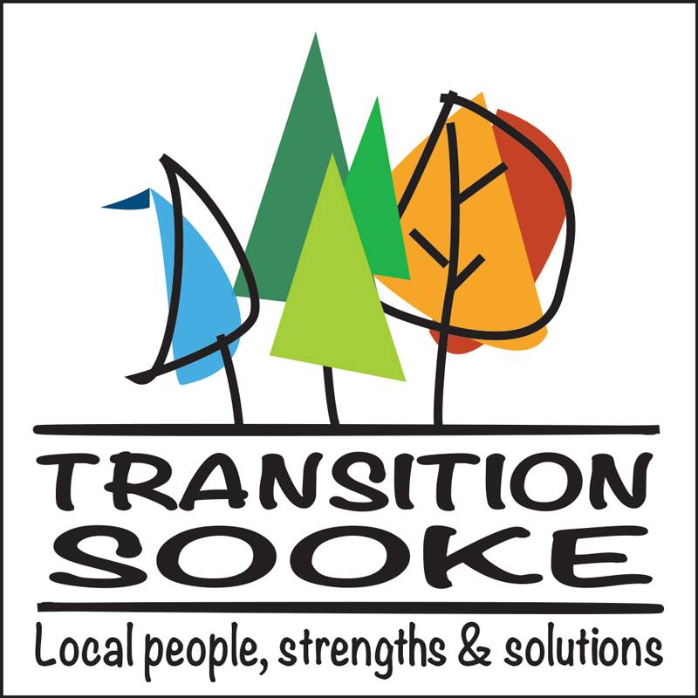

Who are we?
The Sooke Transition Town Society is a citizen’s initiative working to foster, celebrate and (re)build a resilient and sustainable community rooted in Sooke's people, strengths and traditions. In 2011, we were formally recognized by the UK-based Transition Network, founded six years earlier and now representing more than 500 independent yet largely like-minded transition towns across the world. All are dedicated to practical, common-sense steps in response to the following:

Our dependence on fossil fuels
The accelerating impacts of climate change
Our vulnerability to global economic instability

How do we work?
Transition provides a structure and ongoing opportunities for Sooke residents to develop creative solutions to community needs. We're also dedicated to working collaboratively with existing organizations to build local capacity and resilience in the following areas:

community development alternative energy
local jobs and the local economy health transportation
education/reskilling food security housing

What have we done?
Transition Sooke has focused its start-up efforts on awareness raising, education and community engagement under its own name and via its working groups Zero Waste Sooke, Permaculture Sooke, Bike Sooke, the Sooke Region Multi-Belief Initiative and Wild Wise Sooke.

How to get involved?
- Ask about volunteer opportunities with our working groups
- Attend a meeting and share your ideas and passions.
- Join a working group or we can help you start and manage one.

Learn more and contact us

Email: sooketransition@gmail.com (to join our mailing list)
Website: www.transitionsooke.org
Facebook: /transitionsooke

Our Story So Far (selected highlights)

Speaker presentations featuring Andrew Nikiforuk, Starhawk, Guy Dauncey, Fair Vote Canada's David Merner, Sooke foodshed specialists Mary Coll and Mark Zeigler, climate change authority Parvez Kumar, author Kem Luthor, Sierra Club BC's Larissa Stendie, City Green's Glenys Verhulst and GMO whistleblower Thierry Vrain (2011-17)

Sooke Ecohome Tour (2016, 2017, 2018)

Zero Waste Sooke: Sooke Region Earth Day Celebrations (April, 2018); three editions of the Sooke Repair Cafe; six community clean-ups by volunteers; regular appearances at the Sooke Country Market; plastic-reduction and BYOB (Bring Your Own Bag) initiative; workshops for adults and kids at the Sooke library; Talk Trash Community Open Space meeting (April, 2016)

Permaculture Sooke: Two permablitz gatherings; regular meet-ups at Cast Iron Farm (2015/16); workshops at Sunriver Garden; GE-Free Van Isle rally at the Association of Vancouver Island & Coastal Communities Convention (April, 2013).

Bike Sooke: Two editions of the Sooke Slow Food Cycle (2011/2012); installation of bike storage lockers at the Park'n'Ride; bike tune-ups and demos at Sooke Country Market.

Wild Wise Sooke: Bear-aware education campaign by coordinator Deb Read (2015-18)

Co-sponsorship of provincial (2016) and federal (2015) all-candidates' debates

Summer picnic/reskilling fairs (2014-17); annual Awareness Film Night presentation (2011-18)

Various District of Sooke council delegations by TS, Zero Waste and Wild Wise; TS representation on the Climate Change Action Committee and the Community Centre Advisory Committee (2012-18)

Transition Sooke's Open Space Community Think Tank (Oct. 2014)

Campaign for Sooke's successful "No More Tankers" plebiscite + Let BC Vote public forum with David Anderson, Maja Tait, Andrew Moore and Dogwood's Kai Nagata (summer/fall, 2014)

Local Forum on the Economy (Nov. 2012); Sooke Mayor's Candidates Forum (Nov. 2011)

Our first public gathering held at the T'Sou-ke First Nation's solar facility (June 23, 2010)

