First Word edition of PATH
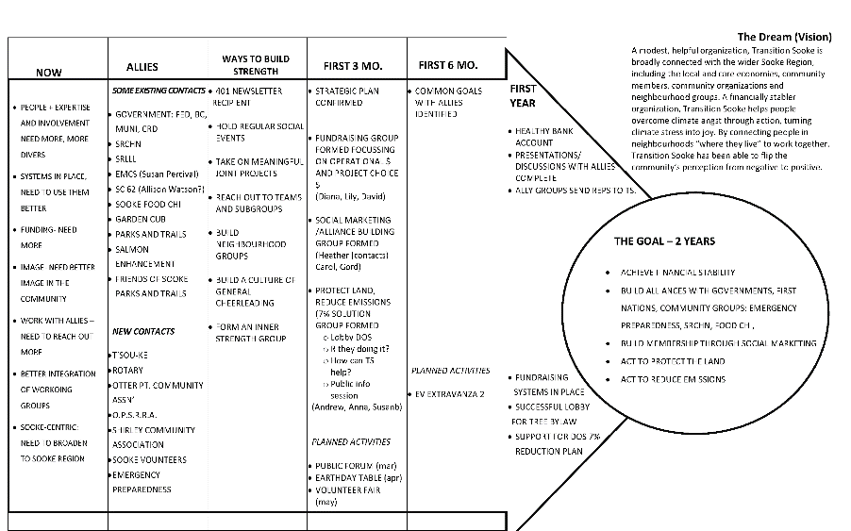
A Note about the PATH Drawing Board
The drawing board pictured above is a modified version of the originally recorded version. Changes were made to improve the quality of images and clarify the board’s content. A major change was made in the “Goal” section, removing some goal details in order to highlight the main theme. In this way “Build Alliances with (list of allies)“ became simply “Strong Alliances”, because the allies in question were already listed in the “Allies” column. Similarly, Build Membership through Social Marketing” became “More Active Members”, with the details spelled out in the “First 3 to 6 Months” column. (which was renamed from the “First 3 months” due to a lack of items in the 6-month column. “Planned Activities” were moved from “from first 3 months to a cut out under “Strength” to accommodate larger writing.
Photographs of both the original recording drawing board, and the revised completed board, as well as a Word rendering of the original have been as addenda to this document.

Photo 1:
Drawing Board as Recorded Jan 22

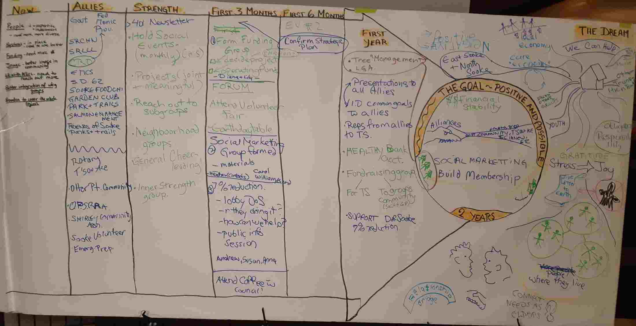

Drawing Board Revised Jan. 30

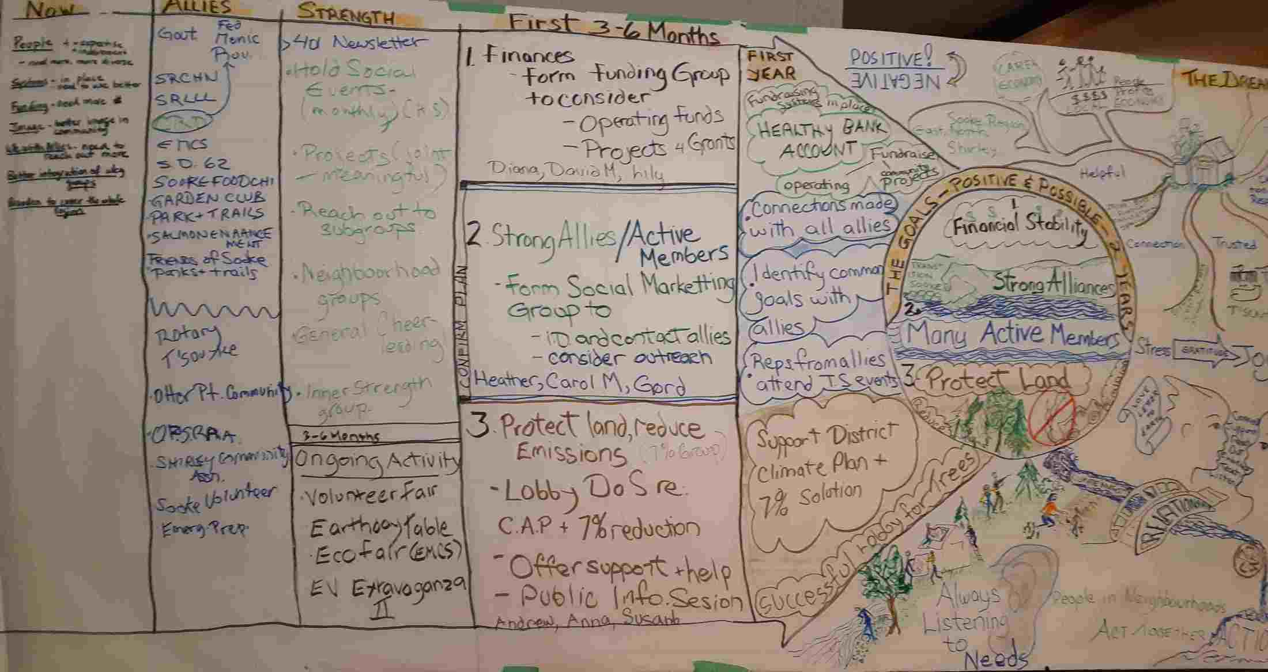

Background Information

The following pages provided background information for event participants. 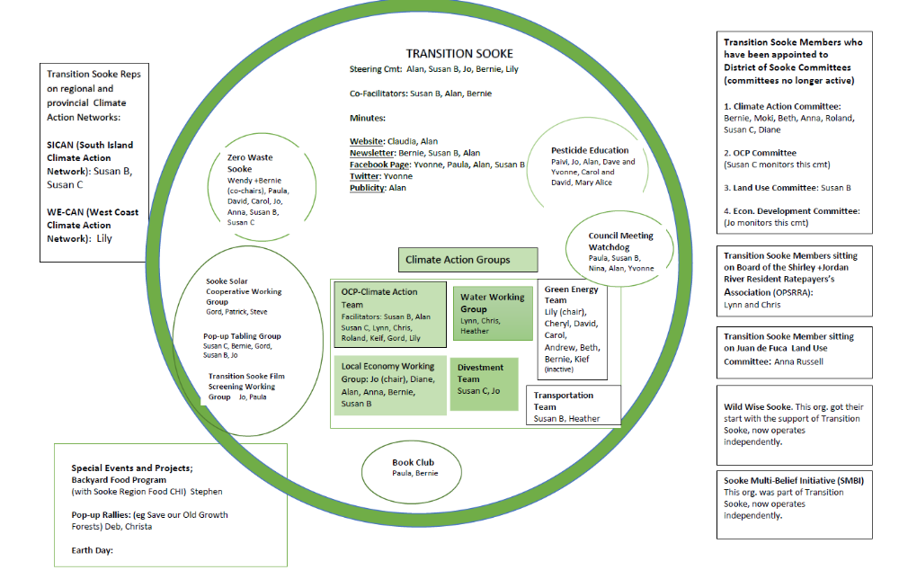

Recent Accomplishments
2019  Green New Deal:  *Green New Deal Town Hall (June 22)  *Green New Deal Organizing Meeting (Aug 7)  *Climate Emergency Workshop: From Green New Deal Town Hall to Community Action (Sept. 29)  EV Extravaganza (March 23)  Sooke Byelection Speed Dating (Sept 15)  Repair Café (Oct. 20)  Rainwater Harvesting and Management Workshop (Nov. 2) | 2020  Earth Day (many planning meetings held; the event itself was cancelled due to COVID lockdown)  Climate Action Teams formed:  *Green Energy Action Team *Fossil Fuel Divestment Action Team  *Transportation Action Team *Rainwater Harvesting Action Team  *Climate Angst and Healing Circle*Green Lifestyle Group  *Forests and Oceans Action Team *Food and Agriculture Action Team  Tour of T-Sou’ke Solar Project (Feb. 8)  TS Table at events:  Awareness Film Night --Pollinators (Feb.12)  Seedy Saturday (Feb. 29)  Backyard Gardens Initiative  World Oceans’ Day “Sooke Orca Pod” pop up event  COVID 19 Times and Lessons Learned (picnic at the Park)  New Working Groups formed:  Sooke Council Watchdog Group  Transition Sooke Climate and OCP Team  Transition Sooke’s Contribution to development of OCP  *Transition Sooke (Susan B) addressed Sooke Council on need for OCP to be developed through the lens of climate emergency (Sept.)  * Stakeholder Meeting with Dialog (Nov.)  Written Response to the Tree Bylaw #795 (December)
2021  OCP:  *Video Stars: taping on-the-street interviews with Sooke residents (Jan/Feb)  *Presentation of “Climate First” document for Sooke Council (Feb)  * Power Point Presentation to DoS’ OCP Advisory Committee: climate action must be overarching framework for Sooke’s OCP (Feb.25)  * Development of Scenario “D” as an alternative scenario to Dialog’s Growth Scenarios for Sooke (March)—press releases, presentations, letters to the editor  *Sooke Town Hall (To Grow or Not to Grow:Developing a Liveable Sooke in a Climate Emergency) June 26  Formation of Water Group  Support to EMCS’ Eco Academy  Initial planning for Climate Solutions Tour (do not take place)  Bus Shelter Climate Change Poster Contest  TS tent at Celebrate Sooke Day (Sept. 18); table at Food Chi’s Apple Festival (Sept. 26)  Opposition to “Lions in the Park” | 2022  OCP:  *Ad placed in Sooke News Mirror urging Council to pass OCP (Sept)  *TS members made presentations in support of OCP at public hearing (Sept)  Craft and Art Supplies Swap (Sept. 18)  Repair Café (May and Oct 16)  Earth Week (April)  Transition Sooke Does All-Candidates’ Meeting with a Twist (Oct. 2)  New Working Groups formed:  *Sooke Solar Cooperative working group established (solar garden at EMCS)  *Transition Sooke Film Screening Working Group  *Transition Sooke Pop-Up Tabling Group  3 Pop-Up Tables to gather public opinion (July, August, Sept.)  Demonstration of waste-free gift wrapping (Dec)  Transition Sooke entry at Santa Claus parade

ABOUT TRANSITION SOOKE

Who we are: Community • Resilience • Climate
Transforming to a just, sustainable society
Transition Sooke is a citizen-based, volunteer, public-interest group focused on co-creating a sustainable, resilient and secure community that meets the challenges of the climate emergency in the Sooke region.

How we do it
Transition Sooke acts as a resource and builds awareness with the Sooke community and with different levels of government to develop creative solutions to sustainability and climate change. Transition Sooke holds virtual and in-person workshops and town halls; makes presentations to Council and its committees; publishes stories and posts in mainstream and social media; develops educational resources; hosts a website and Facebook page; and sends out a monthly newsletter.
Transition Sooke’s members and supporters, who come from diverse backgrounds and experiences, work together co-operatively and democratically to create positive change. Transition Sooke supports and collaborates with other groups and individuals that share its concerns and values.
Transition Sooke believes that the transformation to a new society must not leave anyone behind. Climate and sustainability initiatives and policies need to be just, fair and equitable.
Members of Transition Sooke meet regularly either in-person or online and share progress on ongoing initiatives, discuss new actions, and find out what other relevant activities are going on in the community.

Where we came from
Transition Sooke is part of a worldwide network called Transition Towns, which was founded in Totnes, England in 2005. In 2011, Sooke became the 346th community to be recognized by the Transition Network.

Society Incorporation: The Sooke Transition Town Society (Transition Sooke) was incorporated under the Society Act of BC on Aug. 18, 2011 following two years of preparatory work by John Boquist, Margaret Critchlow, Andrew Moore and Michael Tacon.

Constitution: The name of the Society is Sooke Transition Town Society.
The purposes of the Society are:
- To raise awareness of sustainable living opportunities in the Sooke Region
- To build local resilience in anticipation of climate change, peak oil and economic uncertainty and inequity
- To begin the transition from a carbon intensive lifestyle to a powered down way of living using less non-renewable resources
- To offer educational programming to inform the community
- To contribute to community cohesion and resilience by working in cooperation and collaboration with existing groups and organizations
- To provide similar and related services as determined by the membership

Bylaws
Societies Branch recently affirmed new bylaws for Transition Sooke. We revised our bylaws to create a set of streamlined bylaws that are consistent with the Act (minimum requirement) and truly represent the kind of organization we are.

Policies
Transition Sooke has developed policies to guide us in a more detailed way than in the bylaws. Policies are more easily changed than bylaws, which have to be formally changed at a General Meeting. We are in the process of revising the following polices :
- Membership policy (Approved by Active Members on December 14, 2022)
- Decision-Making Policy (Approved by Active Members on December 14, 2022)
- Financial Procedures Policy (Approved by Active Members on December 14, 2022)

